##### **GUIDELINE TO DEVELOP A HOSPITAL SPECIFIC**

##### **STANDARD OPERATING PROCEDURE**

##### **TO MANAGE COMPLAINTS, COMPLIMENTS AND SUGGESTIONS**

This is a guideline to assist hospitals to develop their own Standard Operating Procedure (SOP) to manage complaints, compliments and suggestions that is in line with the National Guideline to Manage Complaints, Compliments and Suggestions in the Public Health Sector of South Africa.

Hospitals can use this document as a guideline to develop their own facility specific SOP by amending or choosing from the options in the sections as indicated in the guideline.

##### **April 2017**



##### **STANDARD OPERATING PROCEDURE (SOP)**

##### **TO MANAGE COMPLAINTS, COMPLIMENTS AND SUGGESTIONS**

**FOR**

**__________ Hospital (fill in hospital’s name)**

Mr/Ms....................................... ................................

Chief Executive Officer Date approved



Compiled by (author): ..............................

Date for next review: ........................

Table of Contents

1. Introduction 1

2. Procedure for lodging complaints 1

3. Acknowledging complaints 2

4. Recording and Investigating complaints 2

5. Resolving and Redress of complaints 3

6. Monitoring and Statistical data on complaints 5

7. Procedure for recording and management of compliments and suggestions 6

**Table of Annexures**

Annexure A: Complaint, compliment and suggestion form 7

Annexure B: Poster to lodge a complainant, give a compliment or make a suggestion 8

Annexure C: Complaints Register 9

Annexure D: Categories for complaints, compliments and suggestions 10

Annexure E: Complaints statistical data 12

Annexure F: Summary form on outcome of complaint investigation 13

Annexure G: Flow diagram of the SOP to manage complaints 14

Annexure H: Register for compliments 15

Annexure I: Register for suggestions 16

Annexure J: Statistical data on compliments 17

Annexure K: Statistical data on suggestions 18

# Introduction

This standard operating procedure (SOP) describes the steps to follow when managing complaints, compliments and suggestions about the services provided at ______hospitals (fill in hospital’s name). Complaints, compliments and suggestions must be managed appropriately to ensure that problems are identified quickly and managed appropriately to the satisfaction of the patient/family or supporting person who lodged the complaint.

A complaint is defined as the dissatisfaction, displeasure, disapproval or discontent expressed verbally or in writing by any person about the specific health services being rendered and or care being provided within the health sector. The complaints procedure has not been designed to address the following:

* staff–specific grievances that is codified within Labour Relations legislation and thus be addressed through labour relations processes,
* complaints that relate more to broad national health policies, for example the placement and building of new health facilities, the drug regimens for the treatment of specific diseases or disapprovals expressed towards legislation falling under the Portfolio Responsibilities of the Minister of Health, e.g. the Choice on Termination of Pregnancy Act (Act 92 of 1996) and the Tobacco Products Control Amendment Act (Bill 14 of 2015) and
* complaints that relate to corruption which should be referred to the National Anti- Corruption Hotline (NACH).

A compliment is any expression of praise, commendation or admiration given by any person on health services being rendered and or care being provided within the health sector.

A suggestion is any proposal made or an idea that has been put forth by any person to improve the health services being rendered and or care being provided within the health sector.

## Procedure for lodging complaints

* The Quality Assurance/ Public Relations Officer/ Complaints/Help Desk Officer is assigned the responsibility to receive/manage complaints (select the appropriate person for the hospital)
* The public can lodge their complaints :
  + Verbally by calling or speaking to the person responsible for dealing with complaints that will complete a complaint, compliment or suggestion form on behalf of the patient/family or supporting person that wants to lodge a complaint, see Annexure A. This official must always be available to assist vulnerable groups such as illiterate and disabled persons by listening to their complaints and writing it down on the official complaint, compliment or suggestion form. If the patient or their family/ supporting person do not speak the local language, an interpreter must be sought to assist the patient/family or supporting persons to lodge a complaint.
  + In writing by:
* Filling in the complaint, compliment or suggestion form and giving it to the Quality Assurance/ Public Relations Officer/ Complaints/Help Desk Officer or placing it in the complaint, compliment and suggestion box. The box/boxes (choose applicable) are situated at......................... (insert the service areas)
* E-mailing the complaint
* Faxing the complaint
* Posting the complaint
* The poster to inform patients on how to lodge a complaint must be displayed at the entrances/exits and in each ward of the hospital. The poster must be placed next to all complaint, compliment and suggestion boxes and it must be available in at least two local languages. See Annexure B.
* To ensure children’s participation in the complaints process the parents/guardians of the children must be informed that they must request their children to report any complaints to their parents/guardians. Once a child has reported a complaint the parents/guardians must then follow the complaints procedure as set out above and lodge the complaint on behalf of the child.
* To ensure that patients who are disabled, elderly or mentally ill participate in the complaints procedure the person escorting the patient must be requested to report any complaints to their escort. Once the patients has reported a complaint the escort must then follow the complaints procedure as set out above and lodge the complaint on behalf of the patient.

# Acknowledging complaints

* The staff member responsible for managing complaints must acknowledge complaints in writing or telephonically (date and time must be recorded on the complaints form) within 5 working days after receipt of a complaint in cases where the complaint was not handed directly to the responsible staff member.
* When a complaint is acknowledged, the patient/family or supporting persons must be informed of
  + The reference number allocated to the complaint.
  + The estimated time it will take to resolve the complaint.

# Recording and Investigating complaints

1. Opening of complaint, compliment and suggestion boxes
   * + Complaint boxes must be opened daily (change if frequency is different) by the staff member responsible for managing complaints. If boxes are not opened daily, a notice of the schedule for opening of boxes must be displayed on to or next to the box.
2. Recording of complaints

* All complaints received must be read and the details thereof recorded in the Complaints Register, see Annexure C or captured on the web-based software for managing complaints (choose one applicable to your hospital). A completed register for each month must be printed and filed in the complaints file at the end of each month.

c) Action to be taken according to priority

* + The complaint must be assessed immediately upon receipt to identify the severity/risk and the appropriate course of action that needs to be taken.
  + A risk rating of high and medium will be used. Complaints that fall within the criteria set for Patient Safety Incidents will be risk rated as high and all other complaints will be risk rated as medium.
  + Priority will be given to resolving issues that have a high risk and which must be escalated to the CEO/clinical manager with immediate effect. The CEO/clinical manger must escalate complaints that are identified as Severity Access Code 1 patient safety incidents to the provincial within 24 hours. (change if reporting lines differs)

1. Investigation plan

* Each complaint must be investigated. All allegation(s) contained in a complaint must be written down to ensure that all aspects are investigated. It determines the specific issue(s) to be investigated as well as the facts that needs to be obtained to determine the outcome.
* A short plan on how to go about to investigate the complaint must be recorded. The plan should include:
  + who will be responsible to investigate each allegation,
  + who should be interviewed,
  + what records should be reviewed,
  + what questions should be asked.

1. Identify system failures
   * Each complaint will be categorised according to the categories set out in Annexure D to assist the hospital to identify the most commonly occurring system failures.
   * Annexure E must be completed at the end of every month or the report on categories must be generated from the web-based software for managing complaints, compliments and suggestions. (Choose one applicable to the hospital).
   * The data on Annexure E will be used to identify significant system failures. The identified system failures will be analysed to determine the root cause by making use of one of the quality improvement tools as set out in the National Quality Improvement Guideline, page 17. Once problems and gaps have been identified, a Quality Improvement Plan must be developed and implemented.

# Resolving and Redress of complaints

* The complaint will be resolved and the final outcome of the investigation conveyed to the patient/family or supporting persons who lodged the complaint within a target time frame of 25 working days from the date the complaint was received.
* If the complexity of the investigation requires an extension of the 25 days period, the patient/family or supporting persons who lodged the complaint will be provided with a progress report within 25 working days and an estimated date for final response.
* The patient/family or supporting persons who lodged the complaint will be given redress by:
  + Inviting the patient/family or supporting persons who lodged the complaint to a redress meeting. A letter/ report/minutes of the meeting will be provided to the complainant.
  + Provide the patient/family or supporting persons who lodged the complaint with a written letter via e-mail, post or fax.
* Redress should include the following:
  + An apology, explanation and acknowledgement of responsibility
  + Remedial action, which may include review or changing a decision on the service given to an individual; revising published material; revising procedures to prevent the same thing happening again; training or supervising staff; or any combination of these
* A complaint will be viewed as resolved under the following circumstances:
  + Patient satisfied/Redress done: The patient/family or supporting persons who lodged the complaint indicates that he/she accepts the hospital’s response regarding the complaint. When a complaint cannot be resolved to the satisfaction of the patient/family or supporting persons who lodged the complaint, his/her reasons will be carefully documented as well as the attempts that were made to resolve the complaint. The complaints will be escalated to the provincial office for further management if needed. (change if reporting lines differs)
  + Litigation: A patient/family or supporting persons who lodged the complaint indicates during a redress attempt by the hospital that he/she is not satisfied with the resolution and is going to take legal action against the hospital.
  + Patient Safety Incident: It becomes apparent during the investigation that the complaint concerns a patient safety incident which will then be further managed through the patient safety incident management process. Where a complaint is identified as a patient safety incident, the reference number assigned to it in the Patient Safety Incident Register must be recorded in the Complaints Register.
  + Patient/family or supporting person who lodged the complaint cannot be traced: If additional information is required in order to investigate the complaint or to give redress, and the patient/family or supporting person was contacted once a week for three consecutive weeks without success, the complaint will be seen as resolved. The dates and the methods used to contact the patient/family or supporting persons must be documented as such.
* The form to log the processing of the complaint (Annexure F) must be completed or the data must be captured on the web-based software for managing complaints, compliments and suggestions (choose one applicable for the hospital) once the investigation and redress has been finalised in order to have a summary on the management of the complaint.

# Monitoring and Statistical data on complaints

* The forum for reviewing complaints, compliments and suggestions will consist of the following members: (Change if needed)
  + the CEO
  + the Clinical Manager (Chairperson, change if different)
  + complaints/Helpdesk Officer/Public Relations Officer
  + quality assurance manager
  + nursing manager
  + one staff member from allied services
  + one member of the Hospital Board. In the event that the CCSCs is not a stand-alone committee but forms part of other committees that deal with quality improvement, complaints should be put as the first agenda point so that members of the Hospital Board can be excused once the agenda point has been discussed. The monthly or quarterly report that is submitted to the Hospital Board should include a section on the management of complaints (change to apply to the hospital’s setup)
* The terms of reference (TOR) for the forum will be to:
* Develop a SOP to manage complaints, compliments and suggestions
* Identify a designated complaints, compliment and suggestion staff member for the hospital.
* Monitor the hospital’s adherence to the SOP for the management of complaints, compliments and suggestions.
* Ensure the process whereby a complaint is lodged, a compliment is recorded or suggestion is made, is available in the hospital in the form of posters or pamphlets in the official language(s) commonly understood by the communities that are served by the hospital and the procedure is explained to all first time users.
* Ensure the hospital has visible signposting to lead the patient or their families/supporting persons to the point where complaints should physically be lodged or compliments and suggestions be recorded.
* Monitor that complaint investigations are conducted and redress provided within 25 working days.
* Conduct monthly meetings of which the minutes should be recorded. . (change if frequency differs)
* Compile and analyse statistical reports to identify trends.
* Submit monthly statistical reports to the respective district or provincial office (choose applicable). OR complete statistical data on the web-based software (choose applicable).
* Make recommendations to prevent similar future trends as identified in statistical reports.
* Disseminate lessons learned.
* Ensure that regular training of staff on the management of complaints, compliments and suggestions takes place.
* All documents relating to each complaint (including original complaint letter and other correspondence) will be filed in the Complaints file together with a summary of the complaint (as captured on annexure A and F or as generated from the web-based software for managing complaints, compliments and suggestions) on top of the documentation (choose one applicable for the hospital).
* Statistical data on complaints, compliments and suggestions will be recorded every month in the format as set out in Annexures E, J and K and submitted to the district or provincial office (choose applicable). or the reports must be generated from the web-based software for managing complaints, compliments and suggestions. (choose one applicable for the hospital). The statistical data will be presented at the forum for reviewing complaints, compliments and suggestions for discussion on a monthly basis.
* The complaint register as set out in section 4b must be filed together with the monthly statistical complaints’ forms.
* See annexure G contains a flow diagram that explains the SOP for managing complaints as set out in sections 1 to 6

1. **Procedure for recording and management of compliments and suggestions**

* The public can record a compliment or make a suggestion:
  + Verbally by calling or speaking to the person responsible for dealing with complaint, compliments and suggestions. This official will complete a complaint, compliment or suggestion form on behalf of the patient/family or supporting persons, see Annexure A.
  + In writing by:
* Filling in the complaint, compliments, suggestion form and giving it to the Complaint/Help Desk Officer or placing it in the Complaint, Compliment and Suggestion Box. The boxes are situated at......................... (name the service areas)
* E-mailing the complaint
* Faxing the complaint
* Posting the complaint
* The poster to inform the patient/family or supporting persons how to record a compliment or suggestion must be displayed at the entrances/exits and wards of the hospital. The poster must also be placed next to all complaint, compliment, suggestion boxes in at least two local languages. See Annexure B.
* All compliments and suggestions must be categorised, see Annexure D.
* All compliments and suggestions must be recorded in the register for compliments (Annexure H) and suggestions (Annexure I).
* Appropriate action taken on all compliments and suggestions must be recorded clearly in the applicable column in the registers.
* Monthly statistical data on compliments and suggested must be completed at the end of every month and submitted to the district or provincial Office (choose applicable) or the reports must be generated from the web-based software for managing complaints, compliments and suggestions. (choose one applicable for the hospital). The statistical data will be kept and presented at the forum for reviewing complaints, compliments and suggestions for discussion on a monthly basis.

Annexure A: Complaint, compliment and suggestion form

**FORM TO LODGE A COMPLAINT OR RECORD A COMPLIMENT OR SUGGESTION**

|  |  |
| --- | --- |
| **Ref no** | **(office use)** |

|  |  |
| --- | --- |
| **Date completed** |  |

**Do you want to**: Complain Give a compliment Make a suggestion

|  |  |  |
| --- | --- | --- |
| **Details of the person lodging a complaint or recording a compliment or suggestion** | | |
| Surname | |  |
| First Name | |  |
| Contact details | Cell number |  |
| Postal address |  |
| Physical address |  |
| E-mail address |  |
| Service area (e.g ward no, reception, pharmacy) | |  |
| Hospital or clinic file number | |  |
| **If you are submitting on behalf of someone else, please complete the following:** | | |
| Relation to the patient, e.g. mother, etc. | |  |
| Patient’s Surname | |  |
| Patient’s First Name | |  |
| Contact details of the patient | Cell number |  |
| Postal address |  |
| Physical address |  |
| E-mail address |  |
| Service area (e.g ward no, reception, pharmacy) | |  |
| Patient’s hospital or clinic file number | |  |

**Please describe the complaint or give a compliment or make a suggestion.**

* Where possible also record the staff involved and department where the incident took place.

|  |  |
| --- | --- |
| **Date on which the incident took place:** |  |
|  | |
|  | |
|  | |
|  | |
|  | |
|  | |
|  | |
|  | |
|  | |
|  | |
|  | |

_______________________________ ________________________________

Signature of person lodging the complaint Signature of patient

Annexure B: Poster to lodge a complainant, give a compliment or make a suggestion

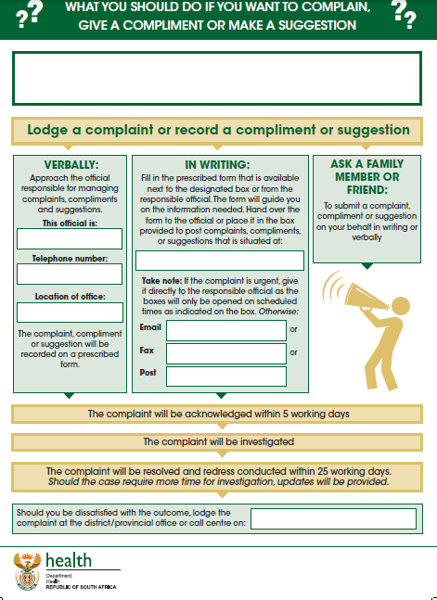

Annexure C: Complaints Register

**Hospital’s name: ______________________________________ Month/year: _____________________**

|  |  |  |  |  |  |  |  |  |  |  |  |
| --- | --- | --- | --- | --- | --- | --- | --- | --- | --- | --- | --- |
| **Ref No.**  **(Column A)** | **Date Received** | **Patient/ family/ supporting person’s name and surname** | **Patient's name and surname** | **Service area where complaint was lodged** | **Summary description of the complaint** | **Information on**  **i.) Action taken, ii) Outcome, iii) Remedial action** | **Category of Complaint** | **Severity of Complaint (Risk Rating)** | **Type of Resolution** | **Date Resolved (Column B)** | **Number of working days to resolve Complaint (Column D)** |
|  |  |  |  |  |  |  |  |  |  |  |  |
|  |  |  |  |  |  |  |  |  |  |  |  |
|  |  |  |  |  |  |  |  |  |  |  |  |
|  |  |  |  |  |  |  |  |  |  |  |  |
|  |  |  |  |  |  |  |  |  |  |  |  |
|  |  |  |  |  |  |  |  |  |  |  |  |
|  |  |  |  |  |  |  |  |  |  |  |  |

**Column name (e.g. A, B and D) in the heading of the complaints register refer to the columns to be completed in Annexure G:**

* **To obtain column A of Annexure G count the number of reference numbers for the month**
* **To obtain column B of Annexure G count the number of complaints resolved (count the rows where dates have been entered). Very important: also check previous month’s registers for complaints that have been resolved for the current month and add all the complaints that have been resolved for the current month. In some instances you can have more complaints resolved than received for a specific month because complaints of previous months were resolved in that specific month.**
* **To obtain column D of Annexure G count the number of complaints resolved within 25 days only. Same principle applies as previous bullet; therefore check previous month’s registers.**

Annexure D: Categories for complaints, compliments and suggestions

|  |  |  |  |  |
| --- | --- | --- | --- | --- |
| **Category** | **Description** | **Example of the type of complaints that could fall under the category** | **Example of the type of compliments that could fall under the category** | **Example of the type of suggestions that could fall under the category** |
| **Complaints/compliments/ suggestions relating to;** |
| 1. **Staff attitude** | The attitude and behaviour that staff display towards patients. | Staff that   * are rude towards * don’t greet or show recognition of presence of the patient or families/support persons * don’t respond to question or enquiry of   patients or their families/supporting persons | Staff that   * were friendly * answered all questions | Improve the attitude of staff by:   * training on Batho Pele * provide courses in courtesy |
| 1. **Access to information** | Patients having access and are provided with information upon request. | Patients not allowed access to their medical records, health information, referral pathways and services provided  Inability to get interpreter for people with speech impairment. | Staff that gave clear information on referral pathways and services provided. | Improve record management ensuring that records are locked at all times. Improve referrals by ensuring that referral pathways are made clear |
| 1. **Physical access** | Patients having access to services. | Establishments that closes before operating times, Patients being turned away without being consulted Patients not referred to higher level of care where indicated | Establishments that stay open even after closing times to ensure that all patients have been consulted | Improve processes within the hospital to ensure that all patients have access by including additional shifts |
| 1. **Waiting times** | Triaging of patients to ensure that waiting times at service areas are managed efficiently. | Long waiting times in queues at service areas  Elderly and disabled persons not given priority treatment | Short waiting times in queues at service areas  Elderly and disables persons are given priority treatment | Reduce waiting times by instituting a booking procedure |
| 1. **Waiting list** | the effective management of waiting list for elective procedures. | Patients put on waiting list for a long period of time before receiving elective procedures as required or scheduled | Waiting list for elective procedures are kept short and on schedule | Shorten waiting lists for elective procedures by contracting in staff from the private sector |
| 1. **Patient Care** | Care and professional treatment provided by health care professional according to clinical protocols/guidelines. | Health care professionals not consulting/assessing patients on schedule as prescribed in treatment protocols  Misdiagnoses of patient’s condition  Not taking care of patient’s personal needs (bathing, feeding)  Elective procedures that resulted in unnecessary harm to patients | Health care professionals adhering to the prescribed protocols, referring patients for second opinions where indicated. Staff that went the extra mile to take care of patient’s personal needs | Improve patient’s care by appointing additional staff, train staff ect. |
| 1. **Availability of medicines** | The appropriate management of stock levels of medicines to prevent stock-outs. | Patients not issued with medication as medicines are out of stock or is expired  Not giving explanation and making alternative arrangements for non-available stock | All medicines available. Where medicines are out of stock alternative arrangements are made to ensure that patients do receive their medication | Improve medicine stock control by conducting weekly stock control to ensure that medicines are ordered in time |
| 1. **Safe and secure environ-ment** | The provision of a safe and secure environment to patients. | Patients assaulted by other patients or visitors  Patients loosing personal possessions while being admitted  Slippery floor, non-availability of appropriate rails at ramps | Security measures are in place to ensure patient’s safety | Improve security levels by appointing additional security staff, train staff |
| 1. **Hygiene and cleanliness** | The provision of a hygienic and clean environment to patient. | Dirty and unhygienic service areas  None-availability of water, toilet papers or soap  Non-availability of linen and dirty linen | Clean service areas  Water, toilet paper and soap is always available | Suggestions to improve the cleanliness of service areas and to ensure that toilet paper are always available |
| 1. **Other** | Any other complaint that cannot be categorised under section 1 to 9. |  |  |  |

Annexure E: Complaints statistical data

**Name of hospital: _____________________ Financial year: ________________________**

|  |  |  |  |  |  |  |  |  |  |  |  |  |  |  |  |  |
| --- | --- | --- | --- | --- | --- | --- | --- | --- | --- | --- | --- | --- | --- | --- | --- | --- |
| **Column name** | **INDICATORS** | | | | | **CATEGORIES** | | | | | | | | | | |
| **A** | **B** | **C** | **D** | **E** | **F** | **G** | **H** | **I** | **J** | **K** | **L** | **M** | **N** | **O** | **P** |
| **Month:** | **# Complaints received** | **# Complaints resolved** | **% Complaints resolved (Column B÷A)** | **# Complaints resolved within 25 working days** | **% Complaints resolved within 25 working days (D÷B)** | **Staff attitude** | **Access to information** | **Physical access** | **Waiting times** | **Waiting list** | **Patient care** | **Availability of medicines** | **Safe and secure environment** | **Hygiene and cleanliness** | **Other** | **Total per month (Sum of Columns F to O)** |
| **April** |  |  |  |  |  |  |  |  |  |  |  |  |  |  |  |  |
| **May** |  |  |  |  |  |  |  |  |  |  |  |  |  |  |  |  |
| **June** |  |  |  |  |  |  |  |  |  |  |  |  |  |  |  |  |
| **Tot Q1** |  |  |  |  |  |  |  |  |  |  |  |  |  |  |  |  |
| **Jul** |  |  |  |  |  |  |  |  |  |  |  |  |  |  |  |  |
| **Aug** |  |  |  |  |  |  |  |  |  |  |  |  |  |  |  |  |
| **Sept** |  |  |  |  |  |  |  |  |  |  |  |  |  |  |  |  |
| **Tot Q2** |  |  |  |  |  |  |  |  |  |  |  |  |  |  |  |  |
| **Oct** |  |  |  |  |  |  |  |  |  |  |  |  |  |  |  |  |
| **Nov** |  |  |  |  |  |  |  |  |  |  |  |  |  |  |  |  |
| **Dec** |  |  |  |  |  |  |  |  |  |  |  |  |  |  |  |  |
| **Tot Q3** |  |  |  |  |  |  |  |  |  |  |  |  |  |  |  |  |
| **Jan** |  |  |  |  |  |  |  |  |  |  |  |  |  |  |  |  |
| **Feb** |  |  |  |  |  |  |  |  |  |  |  |  |  |  |  |  |
| **March** |  |  |  |  |  |  |  |  |  |  |  |  |  |  |  |  |
| **Tot Q4** |  |  |  |  |  |  |  |  |  |  |  |  |  |  |  |  |
| **TOTAL** |  |  |  |  |  |  |  |  |  |  |  |  |  |  |  |  |
| **AVG (Tot/12)** |  |  |  |  |  |  |  |  |  |  |  |  |  |  |  |  |
| **% for financial year (Total of Column F/G/H/I/J/K/L/M/N/O ÷ Total Column P)** | | | | | |  |  |  |  |  |  |  |  |  |  |  |

Annexure F: Summary form on outcome of complaint investigation

|  |  |
| --- | --- |
| **Ref no** |  |

|  |  |
| --- | --- |
| **Manner in which complaint was lodged (mark with an “X”)** | **Written** |
| **Verbal** |
| **Physical visit** |

|  |  |  |  |  |  |
| --- | --- | --- | --- | --- | --- |
| **Date complaint lodged** |  | **Date of acknowledgement** |  | **Number of days to acknowledge complaint** |  |
| **Date complaint resolved** |  | **Number of working days to resolve complaint (date resolved – date lodged)** |  | | |

|  |
| --- |
| **Information on i) Action taken, ii) outcome, iii) remedial action** |
|  |
|  |
|  |
|  |
|  |
|  |
|  |
|  |
|  |

|  |  |  |  |  |  |  |  |  |  |  |
| --- | --- | --- | --- | --- | --- | --- | --- | --- | --- | --- |
| **Category of Complaint(mark with an “X”)** | Staff attitude | Access to information | | | Physical access | | | Waiting times | | Waiting list |
| Patient care | | Availability of medicines | Safe and secure environment | | | Hygiene and cleanliness | | Other | |
| **Risk Rating(mark with an “X”)** | Medium | | | | | High | | | | |
| **Date of redress** |  | | | | | | | | | |

|  |  |
| --- | --- |
| **Type Of Resolution (mark with an “X”)** | **Patient Satisfied/redress done** |
| **Patient Safety Incident** |
| **Litigation** |
| **Patient/family/supporting person couldn’t be traced** |

Annexure G: Flow diagram of the SOP to manage complaints

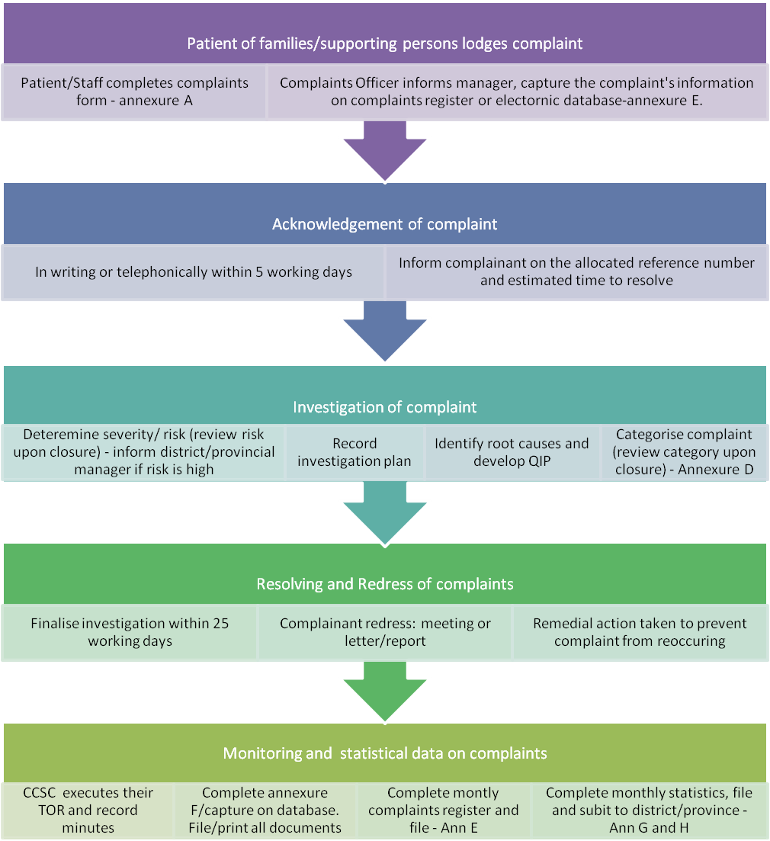

Annexure H: Register for compliments

Hospital’s name: _______________________ Month and year: ______________

|  |  |  |  |  |  |  |  |
| --- | --- | --- | --- | --- | --- | --- | --- |
| **Ref No.** | **Date Received** | **Name & surname of person who recorded the compliment** | **Patient's Name & Surname** | **Service area where compliment originated from** | **Summary description of the compliment** | **Information on**  **action taken** | **Category** |
|  |  |  |  |  |  |  |  |
|  |  |  |  |  |  |  |  |
|  |  |  |  |  |  |  |  |
|  |  |  |  |  |  |  |  |
|  |  |  |  |  |  |  |  |
|  |  |  |  |  |  |  |  |
|  |  |  |  |  |  |  |  |
|  |  |  |  |  |  |  |  |
|  |  |  |  |  |  |  |  |
|  |  |  |  |  |  |  |  |
|  |  |  |  |  |  |  |  |
|  |  |  |  |  |  |  |  |
|  |  |  |  |  |  |  |  |

Annexure I: Register for suggestions

Hospital’s name: _______________________ Month and year: ______________

|  |  |  |  |  |  |  |  |
| --- | --- | --- | --- | --- | --- | --- | --- |
| **Ref No.** | **Date Received** | **Name & surname of person who recorded the suggestion** | **Patient's Name & Surname** | **Service area where suggestion originated from** | **Summary description of the suggestion** | **Information on**  **action taken** | **Category** |
|  |  |  |  |  |  |  |  |
|  |  |  |  |  |  |  |  |
|  |  |  |  |  |  |  |  |
|  |  |  |  |  |  |  |  |
|  |  |  |  |  |  |  |  |
|  |  |  |  |  |  |  |  |
|  |  |  |  |  |  |  |  |
|  |  |  |  |  |  |  |  |
|  |  |  |  |  |  |  |  |
|  |  |  |  |  |  |  |  |
|  |  |  |  |  |  |  |  |
|  |  |  |  |  |  |  |  |
|  |  |  |  |  |  |  |  |

Annexure J: Statistical data on compliments

Hospital’s name: _______________________ Financial year: ______________

|  |  |  |  |  |  |  |  |  |  |  |  |  |
| --- | --- | --- | --- | --- | --- | --- | --- | --- | --- | --- | --- | --- |
| **Column name** | **INDICATOR** | **CATEGORIES** | | | | | | | | | | |
| **A** | **B** | **C** | **D** | **E** | **F** | **G** | **H** | **I** | **J** | **K** | **L** |
| **Month:** | **# Compliment received** | **Staff attitude** | **Access to information** | **Physical access** | **Waiting times** | **Waiting list** | **Patient care** | **Availability of medicines** | **Safe and secure environment** | **Hygiene and cleanliness** | **Other** | **Total per month (Sum of Columns B to K)** |
| **April** |  |  |  |  |  |  |  |  |  |  |  |  |
| **May** |  |  |  |  |  |  |  |  |  |  |  |  |
| **June** |  |  |  |  |  |  |  |  |  |  |  |  |
| **Tot Q1** |  |  |  |  |  |  |  |  |  |  |  |  |
| **Jul** |  |  |  |  |  |  |  |  |  |  |  |  |
| **Aug** |  |  |  |  |  |  |  |  |  |  |  |  |
| **Sept** |  |  |  |  |  |  |  |  |  |  |  |  |
| **Tot Q2** |  |  |  |  |  |  |  |  |  |  |  |  |
| **Oct** |  |  |  |  |  |  |  |  |  |  |  |  |
| **Nov** |  |  |  |  |  |  |  |  |  |  |  |  |
| **Dec** |  |  |  |  |  |  |  |  |  |  |  |  |
| **Tot Q3** |  |  |  |  |  |  |  |  |  |  |  |  |
| **Jan** |  |  |  |  |  |  |  |  |  |  |  |  |
| **Feb** |  |  |  |  |  |  |  |  |  |  |  |  |
| **March** |  |  |  |  |  |  |  |  |  |  |  |  |
| **Tot Q4** |  |  |  |  |  |  |  |  |  |  |  |  |
| **TOTAL** |  |  |  |  |  |  |  |  |  |  |  |  |
| **AVG (Tot/12)** |  |  |  |  |  |  |  |  |  |  |  |  |
| **% for financial year (Total of Column B/C/D/E/F/G/H/I/J/K÷Total Column L)** | |  |  |  |  |  |  |  |  |  |  |  |

Annexure K: Statistical data on suggestions

Hospital’s name: _______________________ Financial year: ______________

|  |  |  |  |  |  |  |  |  |  |  |  |  |
| --- | --- | --- | --- | --- | --- | --- | --- | --- | --- | --- | --- | --- |
| **Column name** | **INDICATOR** | **CATEGORIES** | | | | | | | | | | |
| **A** | **B** | **C** | **D** | **E** | **F** | **G** | **H** | **I** | **J** | **K** | **L** |
| **Month:** | **# Suggestions received** | **Staff attitude** | **Access to information** | **Physical access** | **Waiting times** | **Waiting list** | **Patient care** | **Availability of medicines** | **Safe and secure environment** | **Hygiene and cleanliness** | **Other** | **Total per month (Sum of Columns B to K)** |
| **April** |  |  |  |  |  |  |  |  |  |  |  |  |
| **May** |  |  |  |  |  |  |  |  |  |  |  |  |
| **June** |  |  |  |  |  |  |  |  |  |  |  |  |
| **Tot Q1** |  |  |  |  |  |  |  |  |  |  |  |  |
| **Jul** |  |  |  |  |  |  |  |  |  |  |  |  |
| **Aug** |  |  |  |  |  |  |  |  |  |  |  |  |
| **Sept** |  |  |  |  |  |  |  |  |  |  |  |  |
| **Tot Q2** |  |  |  |  |  |  |  |  |  |  |  |  |
| **Oct** |  |  |  |  |  |  |  |  |  |  |  |  |
| **Nov** |  |  |  |  |  |  |  |  |  |  |  |  |
| **Dec** |  |  |  |  |  |  |  |  |  |  |  |  |
| **Tot Q3** |  |  |  |  |  |  |  |  |  |  |  |  |
| **Jan** |  |  |  |  |  |  |  |  |  |  |  |  |
| **Feb** |  |  |  |  |  |  |  |  |  |  |  |  |
| **March** |  |  |  |  |  |  |  |  |  |  |  |  |
| **Tot Q4** |  |  |  |  |  |  |  |  |  |  |  |  |
| **TOTAL** |  |  |  |  |  |  |  |  |  |  |  |  |
| **AVG (Tot/12)** |  |  |  |  |  |  |  |  |  |  |  |  |
| **% for financial year (Total of Column B/C/D/E/F/G/H/I/J/K ÷ Total Column L)** | |  |  |  |  |  |  |  |  |  |  |  |