South African National Essential Medicine List
Adult Hospital Level Medication Review Process
Component: Emergencies and injuries

MEDICINE REVIEW

Executive Summary
Date: 29 September 2022
Medicine (INN): Ketamine / dissociative analgesic and anaesthetic
Medicine (ATC): N01AX03
Indication (ICD10 code): Dependence on a respirator: Z99.1; Unspecified multiple injuries: T07
Patient population: Intubated adults with trauma on mechanical ventilation in ICU, EC, prehospital
Level of Care: PHC, Adult Hospital Level
Prescriber Level: Clinician (Doctor) and for Emergency Care Practitioners (ECP) and Critical Care Assistants (CCA) (Advanced Life Support Paramedics)
Current standard of Care:
Ketamine as monotherapy: IV/IO Morphine; IV/IO Fentanyl; IV/IO Midazolam + Morphine combined; IV/IO Propofol + Fentanyl; IV/IO Propofol + Morphine
Ketamine as adjunctive therapy: Standard of care: IV/IO Morphine; IV/IO Fentanyl; IV/IO Midazolam + Morphine combined; IV/IO Propofol + Fentanyl; IV/IO Propofol + Morphine
Efficacy estimates: (preferably NNT): 34 NNT Adjunctive Therapy (Mortality), Unknown NNT Monotherapy
Motivator/reviewer name(s): Michael McCaul, Clint Hendrikse, Idriss Kallon, Veranyuy D Ngah
PTC affiliation: CH is member of PTC of Mitchells Plain/Klipfontein Substructure

Key findings
- We conducted a rapid review of clinical evidence on adjunctive or monotherapy ketamine should be used in the treatment for intubated adults with trauma on mechanical ventilation.
- We identified seven systematic reviews addressing adjunctive therapy and one systematic review addressing monotherapy. The most relevant, up-to-date, and highest quality review was used to inform recommendations for critical outcomes.

Adjunctive Therapy:
- Adjunctive ketamine showed a morphine sparing effect (MD= -13.19 µg kg^{–1} h^{–1}, 95% CI -22.10 to -4.28, p<0.001), but no to little effect on midazolam (MD = 0.75 µg kg^{–1} h^{–1}, 95% CI −1.11 to 2.61) or duration of mechanical ventilation in days (MD −0.17 days, 95% CI −3.03 to 2.69, P = 0.91).
- We are uncertain whether adjunctive ketamine therapy reduces mortality (OR 0.88, 95% CI 0.54-1.43, P = 0.60, low certainty of evidence, 5 RCTs, n= 3076 patients) and may result in 30 fewer deaths per 1000, ranging from 132 fewer to 87 more. Ketamine adjunctive therapy results in little to no difference in length of ICU stay (MD 0.04 days, 95% CI −0.12 to 0.20, P = 0.60, high certainty of evidence, 5 RCTs n=390 patients) or length of hospital stay (MD −0.53 days, 95% CI −1.36 to 0.30, P = 0.21, high certainty of evidence, 5 RCTs, n=277 patients).

Monotherapy:
- No evidence found for this review’s prespecified outcomes such as sedation and analgesia, ventilator asynchrony, provider satisfaction, RASS scale mortality and hospital length of stay.
- Monotherapy may improve respiratory outcomes (respiratory depression, chest wall compliance, PO₂, PCO₂) and haemodynamic outcomes (systolic blood pressure, mean arterial pressure, vasopressor use, shock), however, certainty of evidence is very low.

PHC/ADULT HOSPITAL LEVEL EXPERT REVIEW COMMITEE RECOMMENDATIONS:
A: KETAMINE MONOTHERAPY
Type of recommendation |  | We recommend against the option and for the alternative  (strong) |  | We suggest not to use the option  (conditional) |  | We suggest using either the option or the alternative  (conditional) |  | We suggest  using the option (conditional) |  | We recommend  the option  (strong)
 |  |  |  | x |  |  |  | )
Recommendation: The PHC/Adult Hospital Level Committee suggests not to use ketamine as monotherapy for postintubation sedation in intubated adults with trauma on mechanical ventilation (conditional recommendation, very low certainty of evidence).

Rationale: There is uncertainty for benefit and harms for ketamine as monotherapy.
Level of Evidence: Very low certainty
Review indicator: New better quality evidence
B: KETAMINE ADJUNCTIVE THERAPY
 | We recommend against the option and for the alternative  (strong) |  | We suggest not to use the option  (conditional) |  | We suggest using either the option or the alternative  (conditional) |  | We suggest  using the option (conditional) |  | We recommend  the option  (strong)
 |  |  |  |  |  |  | X
Recommendation: The PHC/Adult Hospital Level Committee suggests the use of adjunctive ketamine for postintubation sedation in intubated adults with trauma on mechanical ventilation (conditional recommendation, low certainty of evidence.

Rationale: Ketamine may have benefit as adjunctive therapy but there is uncertainty for benefit and harms as monotherapy.
Level of Evidence: Low certainty of evidence
Review indicator: New high-quality evidence of a clinically relevant benefit or harm
NEMLC RECCOMENDATION – 20 OCTOBER 2022
NEMLC accepted the proposed recommendations, and the NEMLC review report was ratified for external comment (as amended).
Monitoring and evaluation considerations

Research priorities: High-quality RCTs for ketamine use is required for monotherapy, specifically in the prehospital setting for patient important outcomes.

Authors: Idriss Kallon¹, Veranyuy Ngah¹, Clint Hendrikse², Michael McCaul^{1,3}
¹Division of Epidemiology and Biostatistics, Department of Global Health, Stellenbosch University
²Division of Emergency Medicine, University of Cape Town
³SA GRADE Network

Costing analysis: Trudy Leong⁴
⁴ Right to Care consultant supporting NDoH Secreteriat

Declarations of interest: IK, VN, MM, TL have no interests pertaining to Ketamine.

Background

Post-intubation sedation for long periods with Midazolam and Propofol have side effects, especially when patients are already haemodynamically compromised, e.g., a polytrauma patients who are being ventilated. Ketamine is a viable alternative: relatively inexpensive, widely available and fewer haemodynamic side effects. It is currently widely being used, despite it not being in STG/EML for this indication. Its efficacy as standalone or in combination with other agents need to be investigated. As adjunctive therapy, it is currently used as an opioid sparing alternative and as monotherapy it is often used for analgosedation.

Guidance Questions
- Should ketamine be used as an adjunctive therapy in intubated adults with trauma on mechanical ventilation?
- Should ketamine be used as a monotherapy in intubated adults with trauma on mechanical ventilation?

Methods
We conducted a rapid review of evidence for the use of ketamine as 1) adjunctive or 2) monotherapy in intubated adults with trauma on mechanical ventilation. We systematically searched Ovid MEDLINE, Embase and Cochrane on 1 June 2022 for Systematic Reviews (SRs) of Randomized Controlled Trials (RCTs) and RCTs. One search was conducted for both adjunctive and monotherapy questions (Appendix 1), results reported separately. Additionally, we searched the Pan African Clinical Trial registry for any ongoing studies from 2021. Screening of title and abstracts and full text screening, selection of studies and data extraction was conducted independently and in duplicate by two reviewers (IK and CH). Title and abstract, including full text screening was done using Covidence.

AMTSTAR II was used to appraise all the systematic reviews included in the study by a single reviewer (VN), checked by a second reviewer (IK), disagreements resolved by a senior methodologist (MM). GRADE was applied to determine the certainty of evidence and the GRADEpro software was used to generate evidence profiles. Relevant study data were extracted into a narrative table of results. MM, IK, VN and CH reviewed the overall report.

We extracted, where available, effect estimates from included RCTs if not reported by the included SRs to provide clearer benefit and harm EtD judgements. Where possible, we calculated effect estimates (i.e., RR or MD) with confidence intervals in STATA 16 using reported aggregate data from trials. Otherwise, results were reported narratively.

Eligibility criteria for review (Monotherapy)
Population: | Adult 18 years and older trauma patients intubated on mechanical ventilation in ICU, EC or prehospital
Intervention: | Ketamine as monotherapy: IV/IO Ketamine infusion; IV/IO Ketamine bolus and infusion or; IV/IO Ketamine bolus only
Comparator: | V/IO Morphine; IV/IO Fentanyl; IV/IO Midazolam + Morphine combined; IV/IO Propofol + Fentanyl; IV/IO Propofol + Morphine
Outcomes: | Sedation and analgesia, Ventilator asynchrony, provider satisfaction, RASS scale, physiological parameters, Mortality, Hospital length of stay
Studies: | RCTs and SRs

Eligibility criteria for review (Adjunctive)
Population: | Adult 18 years and older trauma patients intubated on mechanical ventilation in ICU, EC or prehospital
Intervention: | Ketamine as adjunctive therapy: IV/IO Ketamine + Morphine infusion combined; IV/IO Ketamine + Propofol infusion combined; IV/IO Ketamine + Fentanyl infusion combined
Comparator: | Standard of care: IV/IO Morphine; IV/IO Fentanyl; IV/IO Midazolam + Morphine combined; IV/IO Propofol + Fentanyl; IV/IO Propofol + Morphine
Outcomes: | Reduction in opioid requirements, Mortality, Hospital length of stay, SAEs and AEs
Studies: | RCTs and SRs

Results
The search yielded 841 records, 9 duplicates were removed, 791 were irrelevant, 41 studies were screened at full text. After exclusion of 28 studies, only 8 Systematic Reviews were included in the final review (Appendix 2). AMSTAR II assessment of all eight reviews ranged from low quality to critically low quality (Appendix 3). Chan et al. (2022) was considered the most relevant, trustworthy and up-to-date review and included GRADE certainty of evidence judgements. Outcomes of interest not reported in Chan et al. (2022) were reported from Manasco et al. (2020) and Wang et al. (2019). All relevant RCTs addressing the research question were found in the systematic reviews included in the study, hence they were excluded from the analysis to avoid double counting. No additional trials were found outside those included in the SRs. Where required, we extracted effect estimates from included RCTs in the SRs

Description of included studies
Table 1 has detailed description of the included studies stratified by monotherapy and adjunctive therapy.

Adjunctive therapy studies
Chan et al. (2022) aimed to assess the impact of continuous ketamine infusion on opioid and sedative consumption in critically ill patients on mechanical ventilation as primary outcome. The review included trials with ketamine as adjunctive therapy (with sedatives or opioids) compared to various standard treatment control combinations. Their secondary outcome was to assess the effect of ketamine on all-cause mortality, the duration of mechanical ventilation, duration of ICU and hospital stay and intracranial pressure elevation. They included 13 RCTs and 6 observational studies with a total of 2258 participants. Risk of Bias (ROB) was well assessed in all included studies using the Cochrane ROB 1.0 tool or ROBINS-I for cohort studies. GRADE was reassessed for critical outcomes namely mortality and length of ICU and hospital stay. GRADE certainty of evidence overall ranged from high to very low certainty across outcomes.

Manasco et al. (2020) assessed Ketamine use in mechanically ventilated patients to determine its effect on sedative use and patient-oriented outcomes. Three RCTs and 12 cohort studies with a total of 892 patients were included in the review.

Wheeler at al., 2020 assessed the efficacy and safety of non-opioid adjunctive analgesia for patience in the intensive care unit. They included 34 RCTs examining various analgesia with only 4 studies evaluating the effect of ketamine as an adjunctive therapy. This study does not mention the number of study participants included in the study.

Wang et al. (2019) conducted a network meta-analysis that determined the effect of sedative drugs on all-cause mortality, duration of mechanical ventilation, and ICU stay, risk of delirium and hypotension in in mechanically ventilated ICU patients. Only one study (and comparison) directly considered Ketamine (with benzodiazepines) with a total of 25 patients.

Patanwala et al. (2017) compared the ketamine and non-ketamine analgesic and sedative effects in mechanically ventilated ICU patients. They included 6 RCTs, 1 cohort study and 6 case reports with a total of 256 patients in their review.

Cohen, et al. (2015) determined the effect of ketamine on intracranial and cerebral perfusion pressure and health outcomes in mechanically ventilated ICU patients. They included 5 RCTs and 5 non-RCTs with a total of 953 patients in the review.

Zeiler et al. (2014) investigated the effect of Ketamine on intracranial pressure in ventilated patients with traumatic brain injury. They included 4 RCTs, 2 cohort studies and 1 case-report with a total of 166 patients.

Monotherapy studies
Miller et al. (2011) assessed the pulmonary and haemodynamic effects of continuous ketamine infusion for sedation maintenance in patients on mechanical ventilation. They included four small RCTs in which the comparator sedative agents were Fentanyl and Midazolam, 11 case series and 5 case reports with a total of 281 patients. Miller provided a narrative report for Ketamine monotherapy with no meaningful effect estimates. We extracted, where reported, meaningful effect estimates from three accessible and included RCTs (Nayar 2008, Allen 2005, Howton 1996) from Miller et al. Effect estimates was only available for blood pressure and other non-prioritised outcomes such as treatment assessment scores.

Internal validity of the systematic reviews and GRADE SoFs
AMSTAR II was used to evaluate the internal validity of the systematic reviews included in the study. In order to reduce the duplication of synthesis, we used the SR that was most recent, was of highest quality and most relevant to our PICO. Chan et al. (2022) and Mancosa et al. (2020) included RCTs relevant to the PICO and any found in the review searches were excluded to avoid double counting. Of all the studies included, Chan et al, (2022) and Mancosa et al. (2020) had the highest AMSTAR II overall score (Low quality review), however Chan was considered in the analysis as this review was the most recent, included the most recent trials, considered the most relevant and used GRADE in reporting its findings. The author team reGRADED the Chan et al outcomes prioritised by PHC EDL committee.

Risk of bias of included trials in SRs
Chan et al (2022) reported high risk of bias across five of the 13 RCTs and high risk of bias across all 6 observational (cohort) included studies. Overall, the ROB was considered to be low to unclear across included trials in Chan 2022. 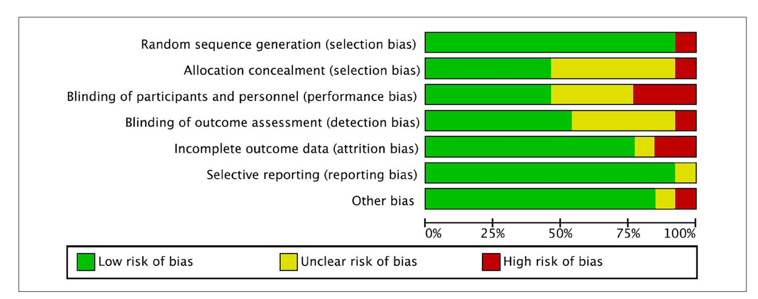
Figure 1: Breakdown of bias of included RCTs using the Cochrane RoB 1 tool (n = 13), Chan et al (2022). Abbreviations: RCT, randomized controlled trials; RoB 1, risk of bias 1.

A: Effect of interventions (Ketamine adjunctive)
Sedation and analgesia
- Morphine consumption
Ketamine as adjunctive therapy reduces the consumption of morphine compared to non-ketamine analgesia therapy (Fentanyl, Midazolam, Sufentanil, Pregabalin) in mechanically ventilated patients (MD= -13.19 µg kg^{–1} h^{–1}, 95%CI -22.10 to -4.28, very low certainty of evidence, 6 RCTS, n=494 participants), which equates to ~1mg/hr less Morphine consumption for an average 70kg adult, ranging from 1.5mg/hr less to 0.3mg/hr less (Chan et al. 2022).
Figure 2: Forest plot of comparison of mean morphine dose for Ketamine vs non-ketamine regime (Chan et al. 2022)
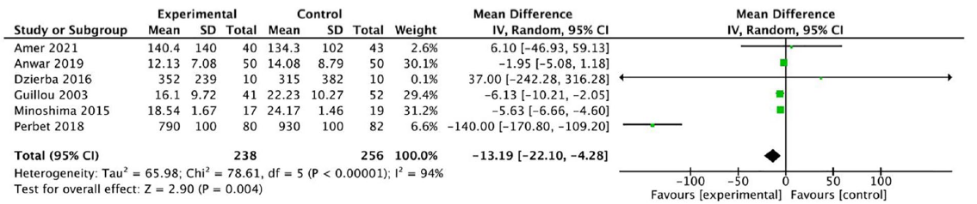
Mean morphine equivalent dose (ME) (µg kg–1 h–1)
- Midazolam consumption: Ketamine has a trivial effect on the consumption of Midazolam compared to non-ketamine analgesia (Fentanyl, Midazolam, Sufentanil, Pregabalin) in mechanically ventilated patients (MD 0.75 µg kg^{–1} h^{–1}, 95% CI −1.11 to 2.61, P = 0.43, very low certainty of evidence, 6RCTs, n=289 patients), which equates to 0.05 mg/hr more Midazolam consumption for an average 70kg adult, ranging from 0.078 less to 0.18 more (Chan et al. 2022). Mancosa et al. 2020 similarly reported no significant effect of Ketamine on the consumption of Midazolam (MD −0.3 mg/h, 95% CI −0.95 to 0.35, p = 0.37, 5 RCTs, n=234 patients)

Figure 3: Forest plot of comparison of mean midazolam dose for ketamine vs non-ketamine regime (Chan et al. 2022)
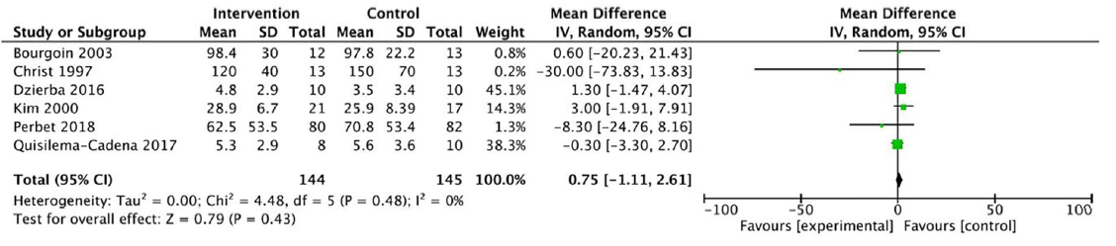
Mean midazolam dose (µg kg–1 h–1)

Mechanical ventilation
There was no significant difference in the duration of mechanical ventilation between Ketamine group and control group (MD −0.17 days, 95% CI −3.03 to 2.69, P = 0.91, very low certainty of evidence, 3 RCTs, n=265 patients) (Chan et al. 2022). No significant difference in duration of mechanical ventilation was also reported by Mancosa et al. (2020), (MD 0.4 days, 95% CI −0.6 to 1.4, p = 0.47, 3 non-randomized studies, n=287).
Figure 4: Forest plot of comparison of mean duration of mechanical ventilation for ketamine vs non-ketamine analgesia (Chan et al. 2022)
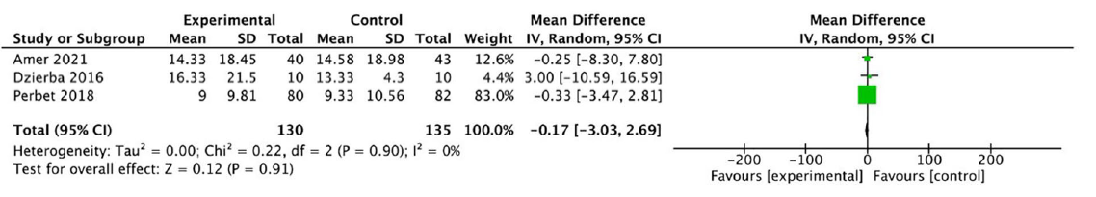

Mortality
Chan et al. (2022) found ketamine adjunctive therapy may reduce mortality (OR 0.88, 95% CI 0.54-1.43, P = 0.60, low certainty of evidence, 5RCTs, n= 3076 patients) resulting in 30 fewer deaths per 1000, ranging from 132 fewer to 87 more. Similar findings were also reported by Mancosa et al. (2020) (OR 1.13, 95% CI 0.70 to 1.81, p = 0.61, 1 RCT, 5 non-randomized studies n= 385 patients).
Figure 5: Forest plot of Ketamine effect on mortality (Chan et al. 2022)
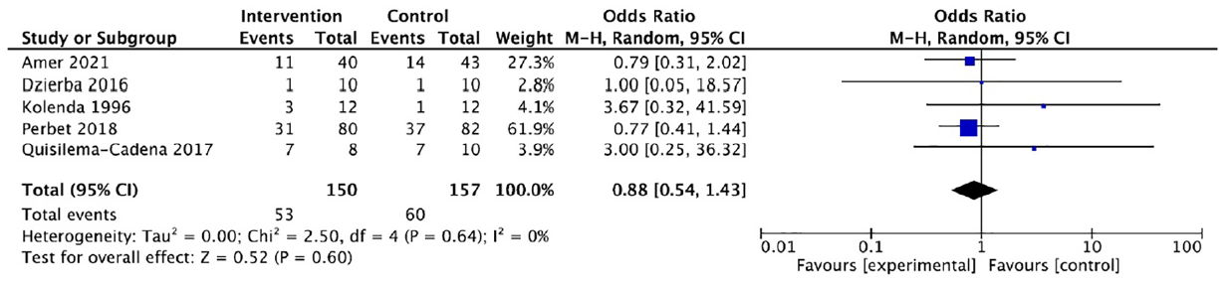
Length of ICU stay (days)
Although Chan et al. (2022) ketamine adjunctive therapy results in little to no difference in length of ICU stay (days) (MD 0.04 days, 95% CI −0.12 to 0.20, P = 0.60, high certainty of evidence, 5 RCTs n=390 patients). Mancosa et al (2020) reported longer stay in ICU with the use of Ketamine, (MD 2.4 days, 95% CI, 1.3–3.5, p<0.001, 2 RCTs, 2 non-RCTs, n= 312 patients). Likely inflated by inclusion of observational data.
Figure 6: Forest plot of Ketamine effect on ICU length of stay (Chan et al. 2022)
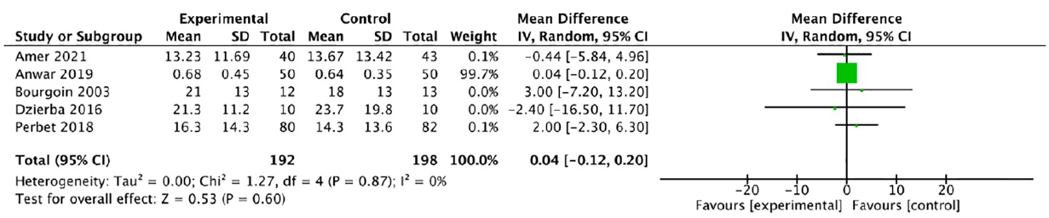

Length of hospital stay (days)
Both Chan et al. (2022) (MD −0.53 days, 95% CI −1.36 to 0.30, P = 0.21, high certainty of evidence, 5 RCTs, n= 277 patients) and Mancosa et al. (2020) (MD 0.5 days, 95%CI -6.0–7.0, p = 0.88, 3 non-randomized studies, n= 173 patients) reported no change in length of hospital stay with the use of Ketamine or that Ketamine adjunctive therapy results in little to no difference in length of hospital stay (days).

Figure 7: Forest plot of Ketamine effect on Hospital length of stay (Chan et al. 2022)
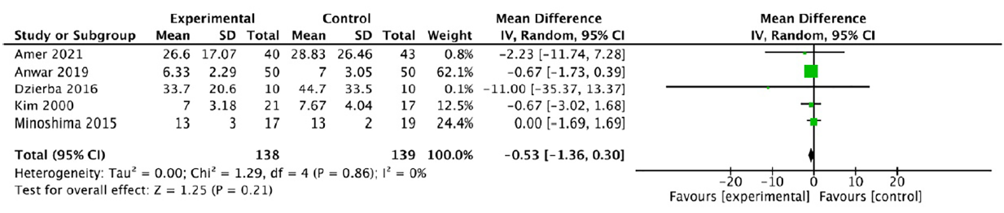
Ventilator asynchrony
Not reported across any systematic review or trials
Provider satisfaction
Not reported across any systematic review or trials
RASS scale
In Mancosa et al. (2020) qualitative analysis was done by one non-randomized study reporting no difference in proportion of time at RASS goal, while another non-randomized study reported greater time within target RASS
Physiological parameters
Not reported across any systematic review or trial

B: Effect of interventions (Ketamine monotherapy)
Overall, the evidence indicated very low certainty (downgraded for ROB, indirectness and inconsistency) that Ketamine monotherapy provides an overall positive effect on respiratory and haemodynamic outcomes. No outcomes were reported for sedation and analgesia, ventilator asynchrony, provider satisfaction, RASS scale, mortality or hospital length of stay. Trials included for monotherapy from the Miller monotherapy SR were very poorly reported with little or no effect estimates.

Respiratory parameters (Miller et al, narrative review)

Respiratory rate changes
3 RCTs reports changes in respiratory rate. 1 RCT (n=60) reported significant higher systolic (F=7.13; df=2.57; P=0.002), and diastolic blood pressure (F=3.6; df=2.57, P=0.034) post induction in ketamine group compared to control (Nayar et al. 2008). 1 RCT (n=44) reported insignificant decrease in systolic (MD 8.1, 95%CI -2.4 to 18) and diastolic blood pressure (MD 2.4, 95% CI -5 to 9.8) (Howtorn et al., 1996). The 3rd RCT reported no significant difference in pulmonary index score between ketamine and control group (MD 0.4 95%CI -0.4 to 1.3) (Allen et al., 2005).

Haemodynamic parameters (Miller et al, narrative review)

Mean arterial blood pressure
2 RCTs (n=29) found an increase in mean arterial blood pressure with continuous ketamine use compared to the control group (Elamin et al., 2007; Kolenda et al., 1996).
Use of Vasopressors
1 RCT (n=24) reported decrease in vasopressor in ketamine group compared to control (Kolenda et al., 1996¹) and another RCT (5 patients) reported decrease in shock with continuous Ketamine use (Elamin et al., 2007¹).
Cerebral perfusion pressure (CPP)
1 RCT found increase in CCP (8 mmHg) with the use of Ketamine compared to control on the first day (Kolenda et al., 1996¹).

Conclusion
The evidence of use of adjunctive Ketamine for post-intubation sedation in intubated adults with trauma on mechanical ventilation shows clinically meaningful morphine sparing effects and may reduce mortality. Ketamine compared to other agents shows little to no difference in ICU or hospital length of stay. Overall, the introduction of adjunctive Ketamine for post-sedation intubation results in a moderate meaningful net benefit.
Monotherapy showed an overall positive effect on respiratory and haemodynamic outcomes, however with very low certainty of evidence. Additionally, we are very uncertain about benefit vs harm profile of monotherapy on critical patient outcomes due to poor trial reporting and lack of meaningful effect estimates.

Evidence to Decision Framework
 | JUDGEMENT | EVIDENCE & ADDITIONAL CONSIDERATIONS
QUALITY OF EVIDENCE OF BENEFIT | A: ADJUNCTIVE THERAPY  What is the certainty of evidence?  High Moderate Low Very low  x | Across critical outcomes (mortality and length of stay) certainty of evidence ranged from low to high. Overall certainty is thus rated as low considering the overall gestalt of the evidence.  See GRADE Evidence Profile.
 | B: MONOTHERAPY  What is the certainty of evidence?  High Moderate Low Very low  x | Evidence not GRADED in SR. AMSTAR score however was critically low quality and overall certainty of evidence likely to be similar.  The evidence indicated very low certainty (downgraded for ROB, indirectness and inconsistency)
EVIDENCE OF BENEFIT | A: ADJUNCTIVE THERAPY  What is the size of the effect for beneficial outcomes?  Large Moderate Small None  x | See GRADE Evidence Profile.  Ketamine compared to either Fentanyl, Midazolam, Sufentanil, Pregabalin.  Mortality: 30 fewer per 1000 (132 fewer to 87 more)  Length of hospital stay: MD 0.53 days lower (1.36 lower to 0.3 higher)  Clinically meaningful morphine sparing effect (MD= -13.19 µg kg^{–1} h^{–1}, 95% CI=-22.10 to -4.28)  Duration of mechanical ventilation: MD −0.17 days, 95% CI −3.03 to 2.69, P = 0.91
 | B: MONOTHERAPY  What is the size of the effect for beneficial outcomes?  Large Moderate Small None/trivial Uncertain  X | Overall positive effect on respiratory (respiratory depression, chest wall compliance, PO₂, PCO₂) and haemodynamic (systolic blood pressure, mean arterial pressure, vasopressor use, shock) outcomes.  Measures of effect not reported in review or in included RCTs, however there may be benefit (above) and congruent with judgements from adjunctive therapy.  Calculated effect estimates from 1 RCT, N= 44) in Asthma patients.  SBP: MD 8.1 (95%CI -2.4 to 18)  DBP: MD 2.4 (95% CI -5 to 9.8)  It is however unclear what the magnitude of beneficial effects are of monotherapy.
EVIDENCE OF HARMS | A: ADJUNCTIVE THERAPY  What is the size of the effect for harmful outcomes?  Large Moderate Small None/trivial  x | See GRADE Evidence Profile  Ketamine compared to either Fentanyl, Midazolam, Sufentanil, Pregabalin.  Length of ICU stay: MD 0.04 higher (0.12 lower to 0.2 higher)  Length of hospital stay: MD 0.53 days lower  (1.36 lower to 0.3 higher)  Small increase in midazolam use: (MD = 0.75 µg kg^{–1}h-¹, 95% CI −1.11 to 2.61)
 | B: MONOTHERAPY  What is the size of the effect for harmful outcomes?  Large Moderate Small None/trivial Uncertain  x | 1 case report found a decrease in systolic blood pressure with continuous ketamine infusion  Size of effect not reported in review or included RCTs
BENEFITS & HARMS | A: ADJUNCTIVE THERAPY  Do the desirable effects outweigh the undesirable harms?  Favours intervention Favours control Intervention = Control or Uncertain  x | Benefit: Moderate  Harms: Small
 | B: MONOTHERAPY  Do the desirable effects outweigh the undesirable harms?  Favours intervention Favours control Intervention = Control or Uncertain  x | Benefit: Uncertain  Harms: Uncertain
THERAPEUTIC INTERCHANGE | Therapeutic alternatives available:  Yes No  x
FEASABILITY | Is implementation of this recommendation feasible?  Yes No Uncertain  x | SAHPRA registered.  Training would be required for recommended use of ketamine as adjunctive therapy in this clinical setting.
RESOURCE USE | How large are the resource requirements?  More intensive Less intensive Uncertain  x | Price of medicines:  Medicine Tender price (ZAR)* 100% OF SEP (ZAR)** 60% OF SEP (ZAR)  Ketamine 500mg/10ml injection, 10 ml 49.20 n/a n/a  Morphine 15mg/ml injection, 1 ml 4.23 n/a n/a  Fentanyl 500mcg/10ml injection, 10ml 10.20 n/a n/a  * Contract circular HP09-2021SD, August 2022 (weighted average prices used where relevant)  Model assumptions:  1. Modelled on a 70 kg adult patient.  2. Duration of therapy estimated as 3 days for analgosedation in emergency care.  3. Drug vehichle and administration set considered to be similar across interventions so not included in the price comparison  4. Wastage considered to be neglible and not factored in the costing model  Comparative cost analysis across treatments (using direct medicine prices only):  - Ketamine 0.5-1 mg/kg/hour = 70mg/hour = 1680 mg/day (using 4 x 500mg/10 ml inj): 3-day course = R590.40  - Morphine, IV infusion, 0.1-0.2 mg/kg/hour = 14mg/hour = 336mg/day (using 67 x 15mg/ml inj): 3-day course = R849.23  - Fentanyl, IV infusion, 1 mcg/kg/hour = 70mcg/hour = 1680mcg/day (using 4 x 500mcg/10ml inj): 3-day course = R122.40
VALUES, PREFERENCES,  ACCEPTABILITY | Is there important uncertainty or variability about how much people value the options?  Minor Major Uncertain  x  Is the option acceptable to key stakeholders?  Yes No Uncertain  x | There is no local survey data, however ketamine is currently in use by clinicians and paramedics across the country.
EQUITY | Would there be an impact on health inequity?  Yes No Uncertain  x

Version | Date | Reviewer(s) | Recommendation and Rationale
Initial | 29 September 2022 | ID, VN, CH, GT, MM | Montherapy: Suggest not to be used as postintubation sedation in ventilated trauma patients.  Adjunctive therapy: Suggest to use as postintubation sedation in ventilated trauma patients.  Rationale: Ketamine may have benefit as adjunctive therapy but there is uncertainty for benefit and harms as monotherapy.

References:
- Abdennor L, Puybasset L. Sedation and analgesia for brain injured patient. Annales Franc¸aises d’Anesthe´sie et de Re´animation 2008;27:596–603. doi:10.1016/j.annfar.2008.04.012.
- Amer, M. et al. Adjunctive ketamine for sedation in critically ill mechanically ventilated patients: an active-controlled, pilot, feasibility clinical trial. Journal of Intensive Care 2021;9(54):1-2. https://doi.org/10.1186/s40560-021-00569-1.
- Bawazeer M, Amer M, et al. Adjunct low-dose ketamine infusion vs standard of care in mechanically ventilated critically ill patients at a Tertiary Saudi Hospital (ATTAINMENT Trial: study protocol for a randomized, prospective, pilot, feasibility trial. Trials 2020; 21(288): 1-13. https://doi/10.1186/s13063-020-4216-4
- Bourenne J, et al. Sedation and neuromuscular blocking agents in acute respiratory distress syndrome. Ann Transl Med 2017;5(14):291. http://dx.doi.org/10.21037/atm.2017.07.19.
- Bourgoin A, et al. Safety of sedation with ketamine in severe head injury patients: Comparison with sufentanil. Crit Care Med 2003;31(3):1-7. DOI: 10.1097/01.CCM.0000044505.24727.16.
- Cohen L, et al. The Effect of Ketamine on Intracranial and Cerebral Perfusion Pressure and Health Outcomes: A Systematic Review. Annals of Emergency Medicine 2015; 65(1):1-11. http://dx.doi.org/10.1016/j.annemergmed.2014.06.018.
- Chan K, et al. Impact of Ketamine on Analgosedative Consumption in Critically Ill Patients: A Systematic Review and Meta-Analysis. Annals of Pharmacotherapy 2022; 00(0):1-20. https://doi.org/10.1177/10600280211069617.
- Chang LC, et al. The Emerging Use of Ketamine for Anesthesia and Sedation in Traumatic Brain Injuries. CNS Neuroscience & Therapeutics 2013; 19:390–395. DOI: 10.1111/cns.12077.
- Elamin EM, et al. Is Ketamine The Right Sedative For Mechanically Ventilated Patients? Chest. 2007;132:574. doi:10.1378/chest.132.4_MeetingAbstracts.574.
- Elamin EM, et al. Impact of ketamine on dynamic compliance and airway resistance of sedated and mechanically ventilated ICU patients. Critical Care 2009, 13(Suppl 1):P404. doi: 10.1186/cc7568.
- Furyk J, Banks C. From other journals: June 2019. Emergency Medicine Australasia 2019; 31(3): 497-500. From other journals: June 2019 - Furyk - 2019 - Emergency Medicine Australasia - Wiley Online Library.
- Gamberini L, et al. Prehospital Airway Management in Severe Traumatic Brain Injury. Air Medical Journal 2019; 38:366−373. https://doi.org/10.1016/j.amj.2019.06.001.
- Garber PM, et al. Continuous Infusion Ketamine for Adjunctive Analgosedation in Mechanically Ventilated, Critically Ill Patients. Pharmacotherapy: The Journal of Human Pharmacology and Drug Therapy 2019; 39(3): 288-296. https://doi-org.ezproxy.uct.ac.za/10.1002/phar.2223.
- Grawe ES, Bennett S. Sedation of Critically Ill Patients Undergoing Mechanical Ventilation 2013; 51(2): 62-80.
- Green SM, et al. Ketamine and Intracranial Pressure: No Contraindication Except Hydrocephalus 2014; 65(1): 52-54. http://dx.doi.org/10.1016/j.annemergmed.2014.08.025.
- Gupta B K, et al. A comparative study of sedo‑analgesic effect of dexmedetomidine and dexmedetomidine with ketamine in postoperative mechanically ventilated patients. Journal of Anaesthesiology Clinical Pharmacology 2022; 38(1): 69-72.
- Islamic Republic of Iran. Comparison of propofol and fentanyl with propofol and ketamine in sedation and analgesia in trauma patients. 2020. IRCT2016112224606N2.
- Kim T, et al. Comparison of the Efficacy between Ketamine and Morphine on Sedation and Analgesia in Patients with Mechanical Ventilation. Korean Journal of Critical Care Medicine 2000;15(2): 82-87. Comparison of the Efficacy between Ketamine and Morphine on Sedation and Analgesia in Patients with Mechanical Ventilation (accjournal.org).
- Kurdistan university of medical sciences. Comparison of the effects of etomidate versus ketamine on outcome of adult patients with multiple trauma requiring rapid sequence intubation. 2022. https://trialsearch.who.int/Trial2.aspx?TrialID=CTRI/2020/01/022959.
- Leone M, et al. What sedation for prevention and treatment secondary brain insult? Annales Françaises d’Anesthésie et de Réanimation 2006; (25): 852–857. DOI:10.1016/j.annfar.2006.03.012.
- Madsen FA, et al. Ketamine for critically ill patients with severe acute brain injury: Protocol for a systematic review with meta-analysis and Trial Sequential Analysis of randomised clinical trials. PLoS ONE 2021; 16(11): 1-14. https://doi.org/10.1371/journal.pone.0259899.
- Manasco, AT. Ketamine sedation in mechanically ventilated patients: A systematic review and meta-analysis. Journal of Critical Care 2020; 56:80–88. https://doi.org/10.1016/j.jcrc.2019.12.004.
- Mamoud HF. Dexmedetomidine Versus Ketamine to Facilitate Non-invasive Ventilation After Blunt Chest Trauma. Cinical trials.gov. 2022. Sedation for Non-invasive Ventilation in Blunt Chest Trauma - Full Text View - ClinicalTrials.gov.
- Matthes G, et al. Emergency anesthesia, airway management and ventilation in major trauma · Background and key messages of the interdisciplinary S3 guidelines for major trauma patients. Unfallchirurg 2012; 115:251-266. DOI 10.1007/s00113-011-2138-z.
- Miller AC, et al. 2011. Continuous intravenous infusion of Ketamine for maintenance sedation. Minerva Anestesiologica 2011; 812-820.
- Neme D, et al. Evidence-Based Guideline for Adult Sedation, Pain Assessment, and Analgesia in a Low Resource Setting Intensive Care Unit: Review Article. International Journal of General Medicine 2020; 13:1445-1452. doi:10.2147/IJGM.S276878.
- Ostermann ME, et al. Sedation in the Intensive Care Unit. A Systematic Review. Jama 2000; 283(11):1451-1459. DOI:10.1001/jama.283.11.1451.
- Pantawala AE, et al. Ketamine for Analgosedation in the Intensive Care Unit: A Systematic Review. Journal of Intensive Care Medicine 2017; 32(6):387-395. DOI: 10.1177/0885066615620592.
- Perbet S, et al. Low doses of ketamine reduce delirium but not opiate consumption in mechanically ventilated and sedated ICU patients: A randomised double-blind control trial. Anaesth Crit Care Pain Med 2018; 37: 589–595. https://doi.org/10.1016/j.accpm.2018.09.006.
- Ramchard, MV. Comparison of intravenous Dexmedetomidine alone versus Dexmedetomidine plus Ketamine combination on sedation, intubation response, safety profile and patient satisfaction during awake fiberoptic nasotracheal intubation. CTRI/2020/01/022959. CTRI Website URL - http://ctri.nic.in.
- Roberts DJ, et al. Sedation for Critically Ill or Injured Adults in the Intensive Care Unit. A Shifting Paradigm. 2012; 72 (14): 1881-1916. Sedation for Critically Ill or Injured Adults in the Intensive Care Unit | SpringerLink.
- Sabertanha A, et al. Comparison of Infusion of Propofol and Ketamine-Propofol Mixture (Ketofol) as Anesthetic Maintenance Agents on Blood Pressure of Patients Undergoing Orthopedic Leg Surgeries. Anesth Pain Med 2019; 9(6):1-6. DOI: 10.5812/aapm.96998.
- Sih K, et al. Ketamine in Adult Emergency Medicine: Controversies and Recent Advances. The Annals of Pharmacotherapy 2011; 45:1525-1534. https://doi.org/10.1345/aph.1Q370.
- Synnot A, et al. 2018. The currency, completeness and quality of systematic reviews of acute management of moderate to severe traumatic brain injury: A comprehensive evidence map. PLoS ONE 2018; 13(6): 1-25. https://doi.org/10.1371/journal.pone.0198676.
- Tobin CDR JM, et al. Anesthesia for Trauma Patients. MILITARY MEDICINE 2018;183 (9/10):32-34. https://doi.org/10.1093/milmed/usy062.
- Wang, H, et al. Sedative drugs used for mechanically ventilated patients in intensive care units: a systematic review and network meta-analysis. Current Medical Research and Opinion. 2019; 35 (3): 435-446. DOI: 10.1080/03007995.2018.1509573. Crit Care Expl 2020; 2:1-8. DOI: 10.1097/CCE.0000000000000157.
- Wang WF, et al. A study of the protective effect and mechanism of ketamine on acute lung injury induced by mechanical ventilation. European Review for Medical and Pharmacological Sciences 2017; 21: 1362-1367. Effects of ketamine on ALI (europeanreview.org).
- Wheeler KE, et al. Adjuvant Analgesic Use in the Critically Ill: A Systematic Review and Meta-Analysis.
- Wolf SE, Arnoldo BD. The year in burns 2011. Burns 2012; 1096-1108. http://dx.doi.org/10.1016/j.burns.2012.10.002.
- Zeiler FA, et al. The Ketamine Effect on ICP in Traumatic Brain Injury. Neurocrit Care 2014; 21:163–173. DOI 10.1007/s12028-013-9950-y.

Appendix 1: Search Strategy
Ovid MEDLINE(R) and Epub Ahead of Print, In-Process, In-Data-Review & Other Non-Indexed Citations, Daily and Versions
1exp Respiration, Artificial/85998
2(mechanical* adj2 (ventilation or ventilated or ventilator)).tw. 61013
3Intubation, Intratracheal/ or (Rapid Sequence Induction and Intubation).mp.38932
4(intubated or intubation).tw.61593
51 or 2 or 3 or 4183883
6ketamine.mp. or Ketamine/22462
75 and 61354
8(random* or factorial* or placebo* or assign* or allocat* or crossover*).tw.1729191
9((blind* or mask*) and (single or double or triple or treble)).tw.212359
10randomized controlled trial.mp. or Randomized Controlled Trial/ 606340
11Controlled Clinical Trial/94882
128 or 9 or 10 or 111924799
13exp animals/ not humans/5010745
1412 not 131727082
157 and 14232
16systematic review*.mp.275861
17(meta-analysis or metaanalysis).mp.245008
1816 or 17394149
197 and 1834
2015 or 19240
Embase
1(exp artificial ventilation/222541
2 (mechanical* adj2 (ventilation or ventilated or ventilator)).tw. 98025
3(Rapid Sequence Induction and Intubation).mp. or endotracheal intubation/ or awake tracheal intubation/ or fiberoptic tracheal intubation/ or nasotracheal intubation/ or respiratory tract intubation/66451
4(intubated or intubation).tw.103611
51 or 2 or 3 or 4340152
6ketamine.mp. or Ketamine/54298
75 and 65079
8(random* or factorial* or placebo* or assign* or allocat* or crossover*).tw.2329913
9((blind* or mask*) and (single or double or triple or treble)).tw.305905
10Randomized Controlled Trial/ or controlled clinical trial/ 902622
11crossover procedure/ or double-blind procedure/ or single blind procedure/ or randomization/ or placebo/654587
128 or 9 or 10 or 112782740
13systematic review*.mp.450614
14(meta-analysis or metaanalysis).mp.361515
15exp ANIMAL/ or exp NONHUMAN/ or exp ANIMAL EXPERIMENT/ or exp ANIMAL MODEL/32727738
16exp human/25006653
1715 not 167721085
1812 or 13 or 143169702
1918 not 172819922
207 and 19733
21(child* or infant* or pediatric).m_titl.1481499
2220 not 21593
Cochrane Database of Systematic Reviews
#1MeSH descriptor: [Respiration, Artificial] explode all trees6880
#2MeSH descriptor: [Intubation, Intratracheal] explode all trees4695
#3(intubated or intubation):ti,ab,kw20699
#4mechanical* and (ventilation or ventilated or ventilator)14361
#5#1 or #2 or #3 or #435762
#6ketamine5978
#7#5 and #6575

Appendix 2: PRISMA
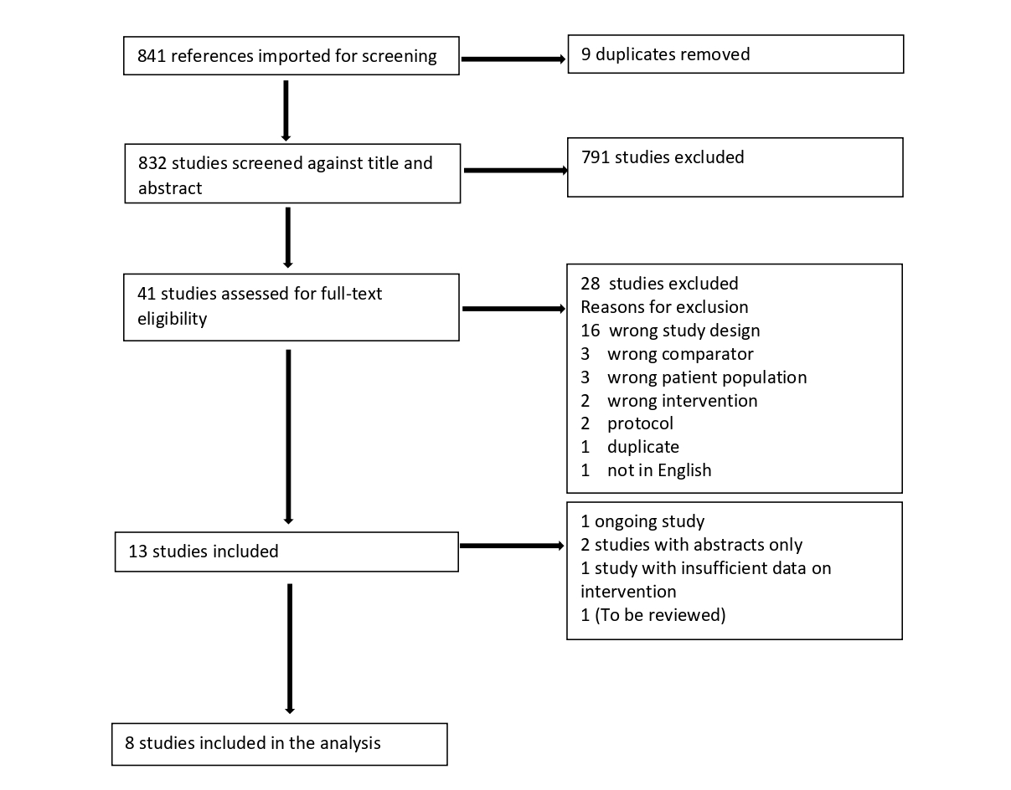

Appendix 3

Table 1: Characteristics of included studies
Citation | Study design | Population | Treatment | Main Findings | Comments
Adjunctive Therapy
Chan et al. “Impact of Ketamine on Analgosedative Consumption in Critically Ill Patients: A Systematic Review and Meta-Analysis” Annals of Pharmacotherapy DOI: 1 1-20 (2022) 0.1177/10600280211069617 | Systematic review | 19 studies  13 RCTs: n=731  6 cohort studies: n=1527  Total n=2258 | Interventions  Ketamine + other sedatives including Morphine, Midazolam, Pregabalin, Propofol, Fentanyl and Remifentanil (various doses)  Control  Fentanyl, Sufentanil, Morphine, Midazolam, Remifentanil, Pregabalin, Propofol and placebo (various doses) | Primary outcomes  Sedative consumption:  Morphine equivalent dose  6 RCTS, n=494  Ketamine group, n=238  Non-ketamine group, n=256  Significant difference between treatment and placebo group  MD= -13.19 mg kg–1 h–1, 95%CI=-22.10 to -4.28, p<0.000 (very low certainty of evidence)  Midazolam  6RCTs, n=289  Ketamine group, n=144  Non-morphine group, n=145  No difference between groups treated with and without ketamine  MD = 0.75 mg kg–1 h–1, 95% CI −1.11 to 2.61, P = 0.43, (very low certainty of evidence)  Mortality:  5RCTS, n=307 patients  No difference between intervention and comparator  Odds Ratio 0.88, 95% CI 0.54-1.43, P = 0.60, (low certainty of evidence)  Length of ICU stay:  5RCTs, n=390 patients  No difference between the ketamine and non-ketamine groups  MD 0.04 days, 95% CI −0.12 to 0.20, P = 0.60, (low certainty of evidence)  There was significant difference in several observational studies, but data not pooled due to bias  Length of hospital stay:  5RCTs, n=277 patients  MD −0.53 days, 95% CI −1.36 to 0.30, P = 0.21, (low certainty of evidence)  There was significant difference in several observational studies, but data not pooled due to bias  Intracranial pressure:  3 RCTs, n=79  no significant difference with ketamine administration  MD 0.72 mmHg, 95% CI −1.92 to 3.36, P = 0.59, (low certainty of evidence)  Duration of mechanical ventilation:  3 RCTs, n=265 patients  Ketamine group, n=130  Non-ketamine group, n=135  No difference between intervention and control  MD −0.17 days, 95% CI −3.03 to 2.69, P = 0.91, (very low certainty of evidence)  MV duration was significantly shorter in one cohort study  median 17.0 vs 7.5 days (no p value reported here)  N= 64 in ketamine group N=120 in fentanyl group | 5 of the 13 RCTs had high risk of bias. 5 RCTs had some concerns of bias and 3 RCTs were judged to have low risk of bias. Assessment of ROB was done using Cochrane RoB 1 tool  All 6 cohort studies were judged to have high risk of bias according to the ROBBINS-1 tool  GRADE assessment for all outcomes reported showed low to very low certainty of evidence
Manasco et al., “Ketamine sedation in mechanically ventilated patients: A systematic review and meta-analysis”. Journal of Critical Care 56 (2020) 80–88. https://doi.org/10.1016/j.jcrc.2019.12.004 | Systematic review | 15 studies  3 RCTS, n=247  12 cohort studies, n= 645  Total n= 892 | Intervention  Ketamine + other sedatives including dexmedetomidine, Midazolam (various doses of ketamine)  Control  Sufentanil, Midazolam, dexmedetomidine and Placebo (various doses) | Primary outcomes  Sedative consumptions:  Ketamine was associated with a significant reduction in Propofol dose  6 studies, n= 325 patients  Ketamine group, n=253  Non-ketamine group, n=272  MD−699 μg/min, 95% CI -1168 to −230, p = 0.003  Ketamine was not associated with a reduction in fentanyl dose  6 studies, n=628 patients  Ketamine group, n=308  Non-ketamine group, n=320  MD=−21.5 μg/h, 95% CI −48.2–5.1, p = 0.11  Ketamine was not associated with a reduction in midazolam dose  5 studies, n= 234 patients  Ketamine group, n=167  Non-ketamine group, n=167  MD= −0.3 mg/h, 95% CI −0.95–0.35, p = 0.37.  Mortality:  6 studies, total n= 385  Ketamine =60/197  Non-ketamine = 61/198  No significant difference between Ketamine group and control group  OR= 1.13, 95% CI 0.70 to 1.81, p = 0.61  Length of ICU stay:  4 studies, n=312  Ketamine group, n= 148  Non-Ketamine group, n=164  Ketamine sedation was associated with significantly longer ICU length of stay  MD= 2.4 days, 95% CI, 1.3–3.5, p<0.001  Hospital length of stay:  3 studies, n= 173  Ketamine group, n=64  Non-ketamine group, n=109  No difference in hospital length of stay  MD= 0.5 days, 95%CI -6.0–7.0, p = 0.88  Mechanical Ventilation:  3 studies, n=287 patients  Ketamine group, n=136  Non-ketamine group, n=151  No difference between groups. MD=0.4 days, 95% CI= −0.6–1.4, p = 0.47  RASS SCORE:  Qualitative analysis  1 study reported no difference in proportion of time at RASS goal  1 study reported greater time within target RASS  Delirium:  2 studies, Total n= 241  Ketamine = 46/119  Non-ketamine= 64/122  OR= 0.48, 95% CI 0.26 to 0.87, p = 0.02 | 1 RCT had low risk of bias and 2 were graded with uncertainty risk of bias according to the Cochrane ROB tool  6 of the cohort studies were graded as high-quality studies and 6 were graded as poor quality according to the Newcastle Ottawa Scale assessment tool.
Wheeler, Kathleen E., et al. "Adjuvant analgesic use in the critically ill: a systematic review and meta-analysis." Critical care explorations 2.7 (2020). https://doi.org/10.1097/cce.0000000000000157. | Systematic review | 34 RCTs,  Number of patients not mentioned  Only 4 studies looked at the intervention of interest, n=unknown | Intervention  Ketamine+ Morphine, Ketobemidone and Remifentanil,  Control  Not stated | Primary outcome  Sedative consumption  2RCTs, n=unknown  Significant difference between Ketamine and control group  MD = -36.8, 95%CI -46.3, -27.3, p,0.000 (low certainty of evidence)  Pain score  2RCTs, n= unknown  No significant difference between ketamine and control group  MD= 0.13, 95% CI -0.46, 0.71, p=0.2 (low certainty of evidence) | Cochrane ROB 1 tool used to assess bias in all included RCTs. 3 of the 4 RCTs with intervention of interest rated as low ROB and 1 as high ROB
Wang et al. “Sedative drugs used for mechanically ventilated patients in intensive care units: a systematic review and network meta-analysis” Current Medical Research and Opinion. 35:3, (2019) 435-446, DOI: 10.1080/03007995.2018.1509573 | Systematic review | 31 RCTs, N=4491  Only 1 study looked at intervention of interest, n= 25 patients with head injury | Intervention  Ketamine + benzodiazepines  Control  Benzodiazepines, placebo, Propofol | Primary outcomes  Mortality  N=12 patients included  4 deaths ketamine vs 3 in placebo  HR=1.46, 95%CI 0.28-8.3  Length of ICU stay  Pooled (network)  MD=2.91 days, 95% CI -9,28-15.2 | The Jade score was used to evaluate the one RCT on intervention of interest and given a score of 4no
Cohen, et al. "The effect of ketamine on intracranial and cerebral perfusion pressure and health outcomes: a systematic review." Annals of emergency medicine 65.1 (2015): 43-51. DOI:https://doi.org/10.1016/j.annemergmed.2014.06.018 | Systematic review | 10 studies  5 RCTs: n=854  5 non-RCTs: n=99  Total N=953 | Intervention:  Ketamine + other interventions including Midazolam, Fentanyl, Sufentanil, Propofol, Methohexitone, Meperidine, Thiopental and Isoflurane  Comparator  Remifentanil, Fentanyl, Etomidate, Sufentanil, and patient’s baseline care. | Primary outcome:  Mortality (28 day)  2 RCTs, n=680 patients  Data not pooled-both studies found no significant difference between Ketamine group and comparison group.  ICU length of stay:  2 RCTs, n=145 patients  Data not pooled-both studies found no significant difference in length of stay between ketamine and control group  Intracranial pressure and cerebral perfusion pressure:  3 RCTs and 5non-RCTs  N=168 patients  Narrative review  4 studies including 2RCTs found no significant difference in intracranial pressure and cerebral perfusion between Ketamine group and control group  One study reported a minimal significant decrease in intracranial pressure but no difference in cerebral perfusion.  3 studies reported significant increase in intracranial pressure in the ketamine group | Methods of assessing ROB in included studies described  Adequate description of risk of bias in included RCTs and non-RCTS  7 of the 10 studies described to have a high risk of selection bias
Patanwala AE, et al. Ketamine for Analgosedation in the Intensive Care Unit: A Systematic Review. Journal of Intensive Care Medicine. 2017;32(6):387-395. doi:10.1177/0885066615620592 | Systematic review | 12 studies  6 RCTs, n=221  1 cohort, n=30  5 case report  Total n=256 | Intervention:  Ketamine + Midazolam, Morphine  Control:  Sufentanil, Midazolam, Fentanyl and Placebo | Primary outcome  Sedative consumption  1 RCT, n=93 patients  Decrease in morphine consumption in intervention group compared to control  MD=22, no 95%CI, p<0.05  Cerebral Haemodynamics (ICP&CPP)  4 RCTs, n=103  3 RCTs reported no difference in ICP and CCP in ketamine group compared to control  1 RCT reported significant increase in ICP by about 2mm/Hg and CPP by about 8mm/Hg in ketamine group | Risk of Bias assessed in all RCTs using Cochrane ROB 1 tool  4 RCTs assessed to have high ROB  1 RCT assessed to have low ROB
Zeiler, F.A. et al. The Ketamine Effect on ICP in Traumatic Brain Injury. Neurocrit Care 21, 163–173 (2014). https://doi.org/10.1007/s12028-013-9950-y | Systematic review | 7 studies  4RCTs, n= 103  2 cohort, n=38  1 case-control, n=25  Total n=166 | Treatment  Ketamine + other interventions including methohexitone, Midazolam  Control  Fentanyl, methohexitone, sufentanil, Midazolam | Narrative review of outcomes  Cerebral Haemodynamics (ICP CPP)  Continuous infusion of Ketamine  4 RCTs, n=103  No significant difference in ICP and CPP between ketamine group and control groups. 2RCTs, n=48 showed increase in CPP  Bolus Ketamine  3 studies, n=63  Trends toward a decrease in ICP. There was no difference in CPP between ketamine group and control group | Risk of Bias assessment not done for RCTs,  GRADE reported for all outcomes

Citation | Study design | Population | Treatment | Main Findings | Comments
Monotherapy
Miller et al. “Continuous intravenous infusion of Ketamine for maintenance sedation”. Minerva Anestesiol 2011;77:812-820 | Systematic review | 20 studies  4 RCTs, n=150 patients  11 case series, n=126 patients  5 case reports  Total n=281 | Intervention  Ketamine maintenance does for >2hours of various doses  Control  Fentanyl + Midazolam | Respiratory parameters  Changes in respiratory rate  6 studies, n=73  No respiratory depression in ketamine group compared to control group  Chest wall dynamic compliance  5 studies, n=41 patients  There was an increase in chest wall dynamic compliance in ketamine group compared to control  Wheezing  6 case reports, n=7 patients  Decrease in wheezing in Ketamine group compared to control  Bronchodilator use  1 case series, n=5 patients  Decrease in bronchodilator use in Ketamine group  Clinical dyspnoea  1 study=53 patients  Decrease in clinical dyspnoea in Ketamine group compared to control  Peak inspirational pressure  5 studies, n=32 patients  Decrease in peak inspirational pressure in Ketamine group  Tidal volume  1 study, n=14 patients  No difference in tidal volume between Ketamine group and control group  Partial oxygenation  10 studies, n=64 patients  Increase in partial oxygenation in Ketamine group compared to control  Partial carbon dioxide  7 studies, n=46 patients  Decrease in partial carbon dioxide in Ketamine group compared to control  Haemodynamic parameters  9 studies, n=102 patients  Blood pressure  2 studies, n=20 patients reported no changes in systolic blood pressure in ketamine group compared to control.  1 case report found a decrease in systolic blood pressure  1 study, n=12 patients found no change in diastolic blood pressure  Mean arterial pressure  3 studies, n=21 patients found no difference in mean arterial pressure.  2 studies, n=29 found increase in mean arterial pressure  Vasopressor  1 study, n=24 patients reported decrease in vasopressor in ketamine group compared to control.  Shock  1 study, n=5 patients reported a decrease in shock in patients treated with continuous Ketamine infusion
Nayar, R. and Sahajanand, H., 2008. Does anesthetic induction for Cesarean section with a combination of ketamine and thiopentone confer any benefits over thiopentone or ketamine alone? A prospective randomized study. Minerva anestesiologica, 75(4), pp.185-190. | RCT (included in Miller) | Pregnant women for elective caesarean section  Total N=60  Number of patients in intervention and control groups not specified.  Exclusion criteria  Patients with known allergies to induction medication  Pregnancy induced hypertension  Pre-eclampsia  Diabetes | Intervention  1mh/kg of intravenous bolus ketamine during anaesthetic induction  Control  5mg/kg of intravenous bolus thiopentone during anaesthetic induction  Combined 0.5mg/kg ketamine and 2.5mg/kg thiopentone bolus on induction | Analgesic effect  No significant difference in VAS pain score post-surgery  Blood pressure  Significant higher systolic blood pressure in ketamine group compared to control groups for 25 minutes post induction  (F=7.13; df=2.57; P=0.002).  Significant higher diastolic blood pressure in ketamine group compared to control groups for 30 minutes post induction  (F=3.6; df=2.57, P=0.034).  Heart rate  Significantly lower heart rate in ketamine group compared to control groups during intubation.  Relevant measures of effect not reported. | High ROB as there is no information on the randomization process and blinding.
Allen, J.Y. and Macias, C.G., 2005. The efficacy of ketamine in pediatric emergency department patients who present with acute severe asthma. Annals of emergency medicine, 46(1), pp.43-50. | Double-blind RCT  (Included in Miller) | Children aged 2-18 years with clinical diagnosis of acute Asthma  Total N=68 patients  Males=41 patients  Females=27  Mean age 6.5 years (SD3.8)  Inclusion criteria  Presenting to the emergency department with acute episodes of wheezing  Exclusion criteria  Temperature >39Cº  Focal infiltrate on chest radiograph  Oral, parenteral, or inhaled glucocorticoids within the previous 72 hours  History of prematurity, bronchopulmonary dysplasia, coexisting primary parenchymal pulmonary disease | Intervention  0.2 mg/kg bolus of intravenous ketamine during 1 to 2 minutes, followed by a 0.5 mg/kg per hour continuous infusion of ketamine for 2 hours  Total N=35patients  Males=20 patients  Females =15patients  Control  Normal saline placebo  Total N=33 patients  Males=21 patients  Females =12patients | Blood pressure  Pulmonary Index Score  No significant difference between Ketamine group and placebo group of pulmonary index score by 2 points 120 minutes  Ketamine group 3.2(SD 2) points  Placebo group 3.6 (SD 1.3) point  MD 0.4 95%CI -0.4 to 1.3 | Some concerns of ROB as allocation concealment in not mentioned and it is unclear
Howton, Joseph C., et al. 1996 "Randomized, double-blind, placebo-controlled trial of intravenous ketamine in acute asthma." Annals of emergency medicine 27.2: 170-175. | Double-blind RCT  (Included in Miller) | Adults aged 18-65 years with clinical diagnosis exacerbation of asthma  Total N=44 patients  Inclusion criteria  Peak expiratory flow of 40% after nebulizer treatment  Exclusion criteria  Chronic obstructive pulmonary disease  Hypertension | Intervention  Intravenous bolus dose of ketamine hydrochloride at 0.2mg/kg over 5-minute period followed by a 0.5mg/kg for an hour  Total N=23patients  Male n=14  Female n=9  Control  Normal saline placebo  Total N=21  Male n=17  Female n=7 | Blood pressure  Decrease in systolic blood pressure in both groups but no significant difference between Ketamine and control group for systolic blood pressure  Ketamine mean 140.1(SD24.1)  Placebo mean 131.9 (SD3.6) (no report of mean difference)  Calculated MD (STATA):  MD 8.1 (95%CI -2.4 to 18)  Decrease in diastolic blood pressure in both groups but no significant difference between ketamine and placebo group for diastolic blood pressure  Ketamine mean 81.9 (SD11.4)  Placebo mean 78.6 (SD13.0)  (No report of mean difference)  Calculated MD (STATA):  MD 2.4 (95% CI -5 to 9.8)  Treatment assessment score by patient  Patient in ketamine group rated their treatment to be more favourable compared to those in placebo group  (4.3, Sd 6 Vs 3.7, sd1.2, respectively; P=.0285).  No significant difference in treatment success score by physician between ketamine and placebo group  3.7, sd 0.6 Vs 3.4 Sd 0.7 | High ROB as there is no mention of allocation concealment and no mention of who was blinded

Appendix 4

Table 2: Characteristics of excluded studies
Citation | Type or record | Reason for exclusion
Abdennor L, Puybasset L. Sedation and analgesia for brain injured patient. Annales Franc¸aises d’Anesthe´sie et de Re´animation. 2008;27:596–603. doi:10.1016/j.annfar.2008.04.012. | Journal article | Wrong study design
Amer, M. et al. Adjunctive ketamine for sedation in critically ill mechanically ventilated patients: an active-controlled, pilot, feasibility clinical trial. Journal of Intensive Care 2021;9(54):1-2. https://doi.org/10.1186/s40560-021-00569-1. | Journal article | Duplicate
Aminiahidashti et al. Propofol–fentanyl versus propofol–ketamine for procedural sedation and analgesia in patients with trauma. American Journal of Emergency Medicine 36 (2018) 1766–1770. https://doi.org/10.1016/j.ajem.2018.01.080. | Journal article | Wrong population
Bawazeer M, Amer M, et al. Adjunct low-dose ketamine infusion vs standard of care in mechanically ventilated critically ill patients at a Tertiary Saudi Hospital (ATTAINMENT Trial: study protocol for a randomized, prospective, pilot, feasibility trial. Trials 2020; 21(288): 1-13. https://doi/10.1186/s13063-020-4216-4. | Protocol | Protocol
Bourenne J, et al. Sedation and neuromuscular blocking agents in acute respiratory distress syndrome. Ann Transl Med 2017;5(14):291. http://dx.doi.org/10.21037/atm.2017.07.19. | Journal article | Wrong study design
Bourgoin A, et al. Safety of sedation with ketamine in severe head injury patients: Comparison with sufentanil. Crit Care Med 2003;31(3):1-7. DOI: 10.1097/01.CCM.0000044505.24727.16. | Journal article | Wrong comparator
Chang LC, et al. The Emerging Use of Ketamine for Anesthesia and Sedation in Traumatic Brain Injuries. CNS Neuroscience & Therapeutics. 2013; 19:390–395. DOI: 10.1111/cns.12077. | Journal article | Wrong study design
Furyk J, Banks C. From other journals: June 2019. Emergency Medicine Australasia. 2019; 31(3): 497-500. From other journals: June 2019 - Furyk - 2019 - Emergency Medicine Australasia - Wiley Online Library. | Journal article | Wrong intervention
Gamberini L, et al. Prehospital Airway Management in Severe Traumatic Brain Injury. Air Medical Journal. 2019; 38:366−373. https://doi.org/10.1016/j.amj.2019.06.001. | Journal article | Wrong study design
Garber PM, et al. Continuous Infusion Ketamine for Adjunctive Analgosedation in Mechanically Ventilated, Critically Ill Patients. Pharmacotherapy: The Journal of Human Pharmacology and Drug Therapy. 2019; 39(3): 288-296. https://doi-org.ezproxy.uct.ac.za/10.1002/phar.2223. | Journal article | Wrong study design
Grawe ES, Bennett S. Sedation of Critically Ill Patients Undergoing Mechanical Ventilation. 2013; 51(2): 62-80. | Journal article | Wrong study design
Green SM, et al. Ketamine and Intracranial Pressure: No Contraindication Except Hydrocephalus. 2014; 65(1): 52-54. http://dx.doi.org/10.1016/j.annemergmed.2014.08.025. | Journal article | Wrong study design
Gupta B K, et al. A comparative study of sedo‑analgesic effect of dexmedetomidine and dexmedetomidine with ketamine in postoperative mechanically ventilated patients. Journal of Anaesthesiology Clinical Pharmacology. 2022; 38(1): 69-72. | Journal article | Wrong population
Kim T, et al. 2000. Comparison of the Efficacy between Ketamine and Morphine on Sedation and Analgesia in Patients with Mechanical Ventilation. | Journal article | Not in English
Kurdistan university of medical sciences. Comparison of the effects of etomidate versus ketamine on outcome of adult patients with multiple trauma requiring rapid sequence intubation. 2022. https://trialsearch.who.int/Trial2.aspx?TrialID=CTRI/2020/01/022959. | Trial registry | Wrong study design
Leone M, et al. What sedation for prevention and treatment secondary brain insult? Annales Françaises d’Anesthésie et de Réanimation. 2006; (25): 852–857. DOI:10.1016/j.annfar.2006.03.012. | Trial registry | Wrong study design
Madsen FA, et al. Ketamin for critically ill patients with severe acute brain injury: Protocol for a systematic review with meta-analysis and Trial Sequential Analysis of randomised clinical trials. PLoS ONE 2021; 16(11): 1-14. https://doi.org/10.1371/journal.pone.0259899. | Journal article | Protocol
Mamoud HF. Dexmedetomidine Versus Ketamine to Facilitate Non-invasive Ventilation After Blunt Chest Trauma. 2022. Cinical trials.gov. Sedation for Non-invasive Ventilation in Blunt Chest Trauma - Full Text View - ClinicalTrials.gov. | Journal article | Wrong intervention
Matthes G, et al. Emergency anesthesia, airway management and ventilation in major trauma · Background and key messages of the interdisciplinary S3 guidelines for major trauma patients. Unfallchirurg 2012; 115:251-266. DOI 10.1007/s00113-011-2138-z. | Journal article | Wrong study design
Neme D, et al. Evidence-Based Guideline for Adult Sedation, Pain Assessment, and Analgesia in a Low Resource Setting Intensive Care Unit: Review Article. International Journal of General Medicine. 2020; 13:1445-1452. | Journal article | Wrong study design
Perbet S, et al. Low doses of ketamine reduce delirium but not opiate consumption in mechanically ventilated and sedated ICU patients: A randomised double-blind control trial. Anaesth Crit Care Pain Med. 2018; 37: 589–595. https://doi.org/10.1016/j.accpm.2018.09.006. | Thesis | Wrong population
Ramchard, MV. Comparison of intravenous Dexmedetomidine alone versus Dexmedetomidine plus Ketamine combination on sedation, intubation response, safety profile and patient satisfaction during awake fiberoptic nasotracheal intubation. CTRI/2020/01/022959. CTRI Website URL - http://ctri.nic.in. | Trial registry | Wrong comparator
Roberts DJ, et al. Sedation for Critically Ill or Injured Adults in the Intensive Care Unit A Shifting Paradigm. 2012; 72 (14): 1881-1916. | Journal article | Wrong study design
Sabertanha A, et al. Comparison of Infusion of Propofol and Ketamine-Propofol Mixture (Ketofol) as Anesthetic Maintenance Agents on Blood Pressure of Patients Undergoing Orthopedic Leg Surgeries. Anesth Pain Med. 2019; 9(6):1-6. DOI: 10.5812/aapm.96998. | Journal article | Wrong comparator
Sih K, et al. Ketamine in Adult Emergency Medicine: Controversies and Recent Advances. The Annals of Pharmacotherapy. 2011; 45:1525-1534. | Journal article | Wrong population
Synnot A, et al. 2018. The currency, completeness and quality of systematic reviews of acute management of moderate to severe traumatic brain injury: A comprehensive evidence map. PLoS ONE. 2018; 13(6): 1-25. https://doi.org/10.1371/journal.pone.0198676. | Journal article | Wrong study design
Tobin CDR JM, et al. Anesthesia for Trauma Patients. MILITARY MEDICINE. 2018;183 (9/10):32-34. | Journal article | Wrong study design
Wang WF, et al. A study of the protective effect and mechanism of ketamine on acute lung injury induced by mechanical ventilation. European Review for Medical and Pharmacological Sciences. 2017; 21: 1362-1367. | Journal article | Wrong study design
Wolf SE, Arnoldo BD. The year in burns 2011. Burns. 2012; 1096-1108. http://dx.doi.org/10.1016/j.burns.2012.10.002. | Journal article | Wrong study design
Kolenda H, Gremmelt A, Rading S, Braun U, Markakis E. Ketamine for analgosedative therapy in intensive care treatment of head-injured patients. Acta neurochirurgica. 1996 Oct;138(10):1193-9. | Journal article | Wrong study design
Elamin, E.M., Huges, L.F. and Drew, D., 2007. Is ketamine the right sedative for mechanically ventilated patients? Chest, 132(4), p.574A. | Poster presentation | Poster presentation

Appendix 5: Certainty assessment
Author(s): M. McCaul. Modified from Chan et al 2022
Question: Ketamine adjunctive therapy compared to standard of care for trauma patients intubated on mechanical ventilation in ICU, EC or prehospital

Certainty assessment |  |  |  |  |  |  | № of patients |  | Effect |  | Certainty
№ of studies | Study design | Risk of bias | Inconsistency | Indirectness | Imprecision | Other considerations | Ketamine adjunctive therapy | standard of care | Relative  (95% CI) | Absolute  (95% CI)
Mortality
5 | randomised trials | not seriousª | not serious | not serious | very serious^{b} | none | 53/150 (35.3%) | 60/157 (38.2%) | OR 0.88  (0.54 to 1.43) | 30 fewer per 1,000  (from 132 fewer to 87 more) | ⨁⨁◯◯  Low
Length of ICU stay (days)
5 | randomised trials | not serious^{c} | not serious | not serious | not serious | none | 192 | 198 | - | MD 0.04 days higher  (0.12 lower to 0.2 higher) | ⨁⨁⨁⨁  High
Length of hospital stay (days)
5 | randomised trials | not serious | not serious | not serious | not serious | none | 138 | 139 | - | MD 0.53 days lower  (1.36 lower to 0.3 higher) | ⨁⨁⨁⨁  High
Ventilator asynchrony - not reported
- | - | - | - | - | - | - | - | - | - | - | -
Provider satisfaction - not reported
- | - | - | - | - | - | - | - | - | - | - | -
CI: confidence interval; MD: mean difference; OR: odds ratio

Explanations
a. Although 3/5 trial had at least one domain with high ROB, Perbet (2018) had overall low ROB and contributed to the majority of the pooled effect.
b. Very serious imprecision: 95% CI of the absolute effect ranges from large benefits to moderate to large harms. Additionally, clinically meaningful inconsistency across included trials (varied direction of effects), undetected statistically (I^2 = 0%), however likely due to small study effects contributing to imprecise trial effect estimates. Not downgraded for inconsistency as linked to imprecision.
c. Anwar contributed 99% of the pooled estimate with overall low ROB

Appendix 6: Overall AMSTAR score for each of the included studies
STUDY | AMSTAR RESULTS
Chan et al. “Impact of Ketamine on Analgosedative Consumption in Critically Ill Patients: A Systematic Review and Meta-Analysis” Annals of Pharmacotherapy DOI: 1 1-20 (2022) 0.1177/10600280211069617 | Low quality review
Manasco et al., “Ketamine sedation in mechanically ventilated patients: A systematic review and meta-analysis”. Journal of Critical Care 56 (2020) 80–88. https://doi.org/10.1016/j.jcrc.2019.12.004 | Low quality review
Wheeler, Kathleen E., et al. "Adjuvant analgesic use in the critically ill: a systematic review and meta-analysis." Critical care explorations 2.7 (2020). https://doi.org/10.1097/cce.0000000000000157. | Critically low-quality review
Wang et al. “Sedative drugs used for mechanically ventilated patients in intensive care units: a systematic review and network meta-analysis” Current Medical Research and Opinion. 35:3, (2019) 435-446, DOI: 10.1080/03007995.2018.1509573 | Critically low-quality review
Cohen, et al. "The effect of ketamine on intracranial and cerebral perfusion pressure and health outcomes: a systematic review." Annals of emergency medicine 65.1 (2015): 43-51. DOI:https://doi.org/10.1016/j.annemergmed.2014.06.018 | Critically low quality
Patanwala AE, et al. Ketamine for Analgosedation in the Intensive Care Unit: A Systematic Review. Journal of Intensive Care Medicine. 2017;32(6):387-395. doi:10.1177/0885066615620592 | Critically low quality
Zeiler, F.A. et al. The Ketamine Effect on ICP in Traumatic Brain Injury. Neurocrit Care 21, 163–173 (2014). https://doi.org/10.1007/s12028-013-9950-y | Critically low quality
Miller et al. “Continuous intravenous infusion of Ketamine for maintenance sedation”. Minerva Anestesiol 2011;77:812-820 | Critically low quality

Ongoing studies
Madsen et al. “Ketamine for critically ill patients with severe acute brain injury: Protocol for a systematic review with meta-analysis and Trial Sequential Analysis of randomised clinical trials”
Brief summary: This study is a systematic review of randomised clinical trials assessing the beneficial and harmful effects of ketamine for patients with severe acute brain injury.
Study type: Systematic review

Note that full-text RCTs could not be sourced.

