South African National Essential Medicine List
Adult Hospital Level Medication Review Process
Component: Emergencies and injuries
EVIDENCE SUMMARY

TITLE: TEMPERATURE CONTROL IN POST-CARDIAC ARREST

Preventing fever post CPR vs therapeutic hypothermia

A systematic review was published in 2022 for the European Resuscitation Council (ERC) and ILCOR (international liaison committee on resuscitation).(1) They followed the Grading of Recommendations Assessment, Development, and Evaluation (GRADE) approach to assess the certainty of evidence and grade recommendations. They found the following:

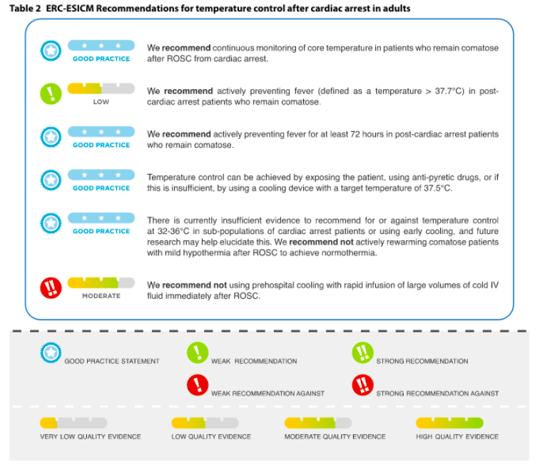
For the STG/EML:
- Proposed wording: from “cooling” to “prevent fever”.
- This is based on the best evidence that exists on this topic and may save resources.

Details of main trial including TTM2 trial:

The evidence for therapeutic hypothermia post CPR was based on two trials – both with significant limitations and biases:
- The Bernard trial was a small quasi randomised trial with substantial methodological limitations.
- The HACA trial was a larger RCT and found a 14% mortality reduction with therapeutic hypothermia (absolute benefit). Significant bias: this trial was unblinded; withdrawal of care was not standardized – pts on the treatment arm had longer times to neuroprognostication; care was not standardized between the two arms.
- A few trials showed net harm or no benefit, including the TTM1 trial.

The TTM2 trial was a large trial – well conducted – nearly 2000 patients and compared hypothermia (33 degrees vs normothermia (fever control).(2) In the control group, they initiated cooling when the temperature rised above 37.8 degrees only and only cooled to 37.5 (normothermia).
This trial had a very low risk of bias as the treatment and neuroprognostication procedures were standardized. It was a multicentered randomised superiority trial. Outcomes were assessed at 30 days and 180 days. Research question: Does targeted hypothermia lead to improved outcomes in comparison to targeted normothermia (and avoidance of fever) in patients with ROSC after OHCA? (return of spontaneous circulation and out of hospital cardiac arrest)

Main findings:
- Hypothermia had no effect on mortality or neurological endpoints.
  - Death from any cause: 50% in hypothermia vs 48% in normothermia, RR 1.04 95% CI 0.94 to 1.14 p=0.37
- Numerous signs of iatrogenic harm in hypothermia group
  - Patients in the hypothermia group had a higher risk of arrhythmia causing hemodynamic instability (24% vs. 17%, p<0.001).
  - Patients in the hypothermia group required paralytics more often (66% vs. 45%, p<0.001).
  - Patients in the hypothermia group had a longer median length of mechanical ventilation (3.8 days vs. 2.9 days).
  - Patients in the hypothermia group experienced more than twice as many unexpected severe adverse events (3.7% vs. 1.4%, p=0.003).

Conclusions
- Therapeutic hypothermia can cause substantial harm.
- Therapeutic hypothermia is resource heavy: cooling vests, ice packs, invasive monitoring, and staff)
- TTM2 trial is the highest level of evidence on this topic.

Low certainty evidence

References
1. Sandroni C, Nolan JP, Andersen LW, Böttiger BW, Cariou A, Cronberg T, et al. ICM RAPID PRACTICE GUIDELINE ERC-ESICM guidelines on temperature control after cardiac arrest in adults. Intensive Care Med [Internet]. 2022;48:261–9. Available from: https://doi.org/10.1007/s00134-022-06620-5
2. Dankiewicz J, Cronberg T, Lilja G, Jakobsen JC, Levin H, Ullén S, et al. Hypothermia versus Normothermia after Out-of-Hospital Cardiac Arrest. N Engl J Med. 2021;384(24):2283–94.

Author: Dr Clint Hendrikse
Date: 9 August 2022

